Weekend
with Wm.


Reaching Our Zenith

Friends Become Family.
Souvenir Book 2022

Weekend 21 |
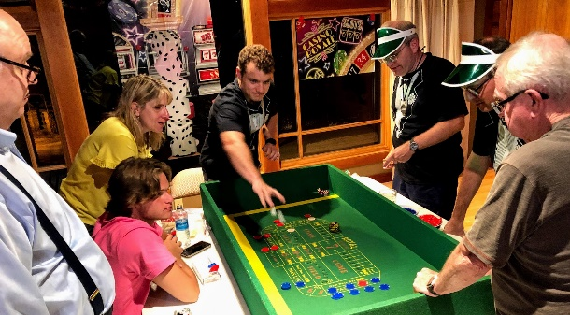
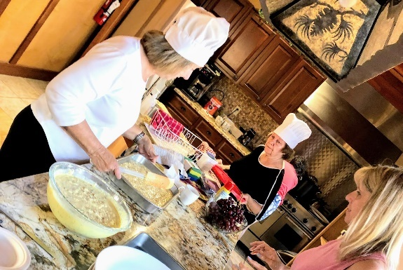
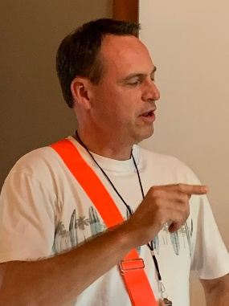
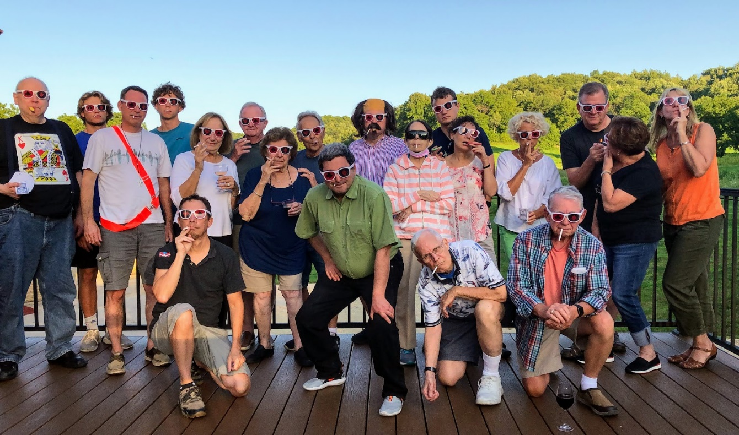
The Peach Bellini Casino and Hideaway

To Fran!
We topped ourselves once more. As you’ll see in our photo album, it was a Weekend lousy with winners — and not just at the tables — including:
- Malvolian of the Year | Erik Nazar
- Kocktail Kontest | Jennifer, Tuaca Tuscan Spice. Other entries: White Negroni (Bryan), 3PB (YOS), Death in the Afternoon (Wayne)
- Gown of Humility | Fred
And we even had the media following us around. (Not, we hasten to add, for the ‘police reports’ page.)
| Malvoliating

A Chair
I hold Papa’s chair
I sit on a chair also
Therefore I am chair
| Erik Nazar
Malvolian of the Year

Shining Brow
On foot we travel
Learning more
On Frank Lloyd Wright tour
Much to see
In amongst the trees
Rhubarb grows
Near Midway Barn
Bugs, bugs darn
Grace was chat chat chat
Floppy hat
We learned a lot
Grace chat NOT!
| Julie

Limerick
Enjoying all the frivolities
While waiting for the whistle to blow
It’s time to go
We’ll never know
The surprise in the show
| Joe

August 14th, 6am
Without an East wind
Or a West wind to pull us
We fly true North we
| Mike

Untitled
A perseid flares!
That was a seven or eight!
I didn’t see it.
| Bryan

Untitled
Cedar Valley Lodge
Has seen many folks like us
It’ll never be the same
| Tommye

Diced Fate
Chips churn. You’re up, then
You need replaced ricotta
And trees attack you
| YOS

Blinking Grace
Blink blink Grace blink blink
Blink blink blink blink blink blink blink
Blink blink blink blink blink
| Julie

Weekend Fun
Casino it is
Win or lose
No time for snooze
Win or lose
Always time for booze
Win or lose
There’s always next year.
| Julie

Drift Less
Float more! Dam it all
Taliesin, lake swimming
Driftless savannah
| MJ

Behold our Leader
Compliments to John
Who brings together each year
Friends and family
| Anon

Confidence
Blackjack wow simple
Craps is the easiest thing
I just sold my pants.
| YOS

| Our Tagline Suggestions
Friends become family | Julie [Winner!]
Weekend – ever changing, always a blast
Drift Less | Joe
Let’s do it again next year | Mick
A bucolic spectacle – now with more all-terrain vehicles! | A Friend
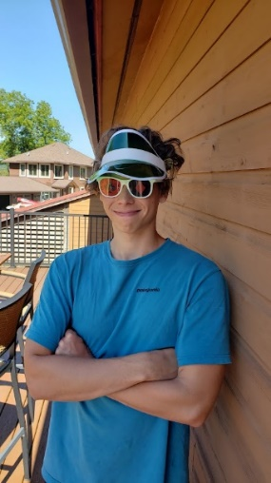
Don’t count your chips before the end.
Let’s gamble: Addictions are great! | Fred
You will enjoy it a lot if you don’t get shot. | Dave
Rosemary – the champagne of Italy | MJ
The house took my money, but not my family | Alex
Now with septic vents! | YOS
Go all in if you want to go to bed. | Alex
The most complicated way to have fun, bar none!
Hot hot hot | Erik Nazar
Open the windows and let me in | Tommye

| Before coming here, I was sure I would embarrass myself by …
- Blocking up the “loo” | Julie
- Saying something I’d regret
- Overeating | Joe
- Not knowing what we were doing | Mick
- Not bringing everything for Saturday dinner. | Rosemary
- Wondering from my room to the shower while underdressed. | A Friend.
- Being the Booby – did it!
- Not knowing how to play craps. | Fred
- Pretty much everything. | Dave
- Forgetting to flush the toilet. | MJ
- Forgetting my pills and other absolutely needed stuff. | Wayne
- Stinking up the bathroom. | Alex
- Showing up wearing a Hawaiian shirt and hula skirt.
- Not looking good! | Tommye
- Sleeping around like a dime store floozy | YOS
- Not knowing how to play. | Alex
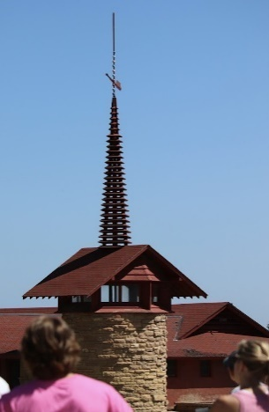
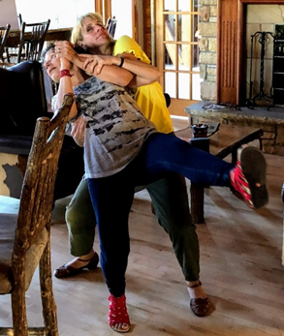
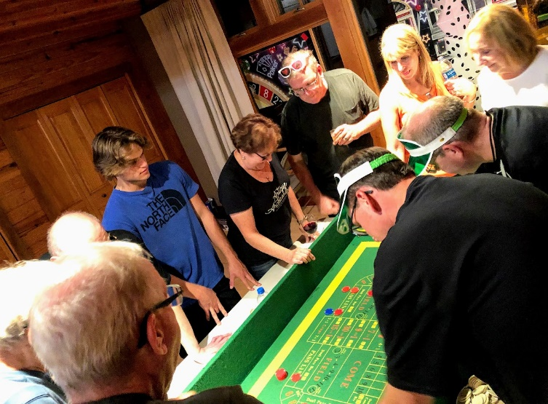

| Topping off 21
Who needs Deb Dicke? | Said entirely in jest, we assure you, as Bryan carried on the Cheese Tradition.
Did someone just join us? | Alex H very quietly when we realized there was one more silhouette than we expected in the darkness.
I’ve done this before. I should know better.
Moronis: The dimmest star in the constellation Dufus.
We may be a pharmacy right here. | Sharon, when Tommye realized she didn’t bring her pills
The trees started choking the prairies, encroaching. | Docent Grace
Art circles and spotlights? Or silos and septic vents? | Urban vs. rural perspectives perhaps.
I hope your favorite color isn’t blue. | Jennifer
Be taller!
The man in the black box made me do it. | Jennifer explaining her dancing
Tips! Tips! Tips!
Hot table
And the Top of the Tops …
Not to change the subject, but is that a septic field? | Jennifer
| Some suggestions for Weekends to come
Pizza night Friday, Mexican night, birdwatching, drumming, fire pit night, special awards for workers, September, closer to home, bags, bocce
Wending our Way
through
Weekends Past

An Ongoing Performance of Middle-Brow Acts, High Drama, and Low Comedy
(To say nothing of the plays)

I. Framboise, Stilchester and an Open Hotel Window: It Begins
Coriolanus, Love’s Labor Lost
II. The Pixelated Weekender
Merchant of Venice, Romeo and Juliet
III. Waterpark!
As You Like It, King Lear
IV. Grady’s Triple Cripple Family Fun Park
Hamlet, Two Gentlemen of Verona
V. Ewww Lake ‘Evergreen’
GoH: Most Pretentious Wine Label.
Deb Dicke / Twelfth Night, MacBeth
VI. The Weekend Drink Contest | Tewkesberry Slushies
GoH: Photo Scavenger Hunt. Ed Ludwig / Pericles, Julius Caesar
VII. Match Game 1675 | Pontoon Fiasco
GoH: Questions, questions. Kurt Dicke /
Much Ado About Nothing
VIII. Spring Green Cabins | Allen Ludden | River tubes
GoH: White Elephant Exchange. Steve Kulm /
A Midsummer Night’s Dream
IX. Discovering the Lodge | The Weekend Olympiad
GoH: Children’s games. YOS /
The Comedy of Errors
X. ‘Weekend’s Got No Talent’ | Clam Bake
GoH Contest: Scavenger Hunt. Kurt Dicke / As You Like It

XI. It’s Family Game Night
GoH ????: Bryan Schneider / The Taming of the Shrew
XII. The Twisted Olive Supper Club |Movie Night |Bataan Death Cruise GoH: Shakespeare Trivia Contest Deb Dicke (remotely)
XIII. Our Old Timey Picnic
GoH: Animal pictures. Tommye Hoffman /
Too Many Husbands
XIV. Burr House | Victorian Games | Mackinaw Winery
GoH: Charades. Chris Hage /
Much Ado About Nothing
VX. Ah the Vrooman | A Vaudeville Murder Mystery
GoH: The Liar Game. Wayne Hoffman / Richard II
VXI. Mystery Night with the Beverly Hillbillies | Civil War Bloomington
GoH: Talent contest. Mary Jo Mikottis / Ms. Hamlet
XVII. Paint n Sip | Allerton Estate
GoH: ‘Least Realistic Mushroom.’ Wayne Hoffman /
A Midsummer Night’s Dream
XVIII. The Laffstock Comedy Barn Players |
Frank Lloyd Warehouse
GoH: ‘Know Your Government?’ Quiz.
Mike Mikottis /Measure for Measure
XIX. Aloha Weekend! | ‘Hips of Kilauea’ Contest
GoH: Hula Pride. Rosemary Spina /
She Stoops to Conquer
XX. WiFiW | Zooming through 2020
XXI. Peach Bellini Casino and Hideaway | Taliesin Tour
GOH: /Fred Nazar
‘O brave new world | That has such people in it!’ -Wm.
+++
Weekend I | It begins!
The Weekenders: Deb, Kurt, Tom, Bryan, Sharon, Bret, Mike, Mary Jo, Amy, Your Obedient Servant.
… Discovering framboise ▪ First exposure – on Coriolanus – to the Gown of Humility ▪ Defenestrating from the Best Western ▪ Woodchips ▪ Metabolizing during Love’s Labor Lost ▪ A fine firehouse dinner

Weekend II
The Second Annual Weekend With Wm.
(In Other Ways Styled The Stilchester and Framboise Festival)
Friends, Romans, Countrymen –
The play’s the thing! That, plus the fancy cheeses and pretentious after-dinner wines.
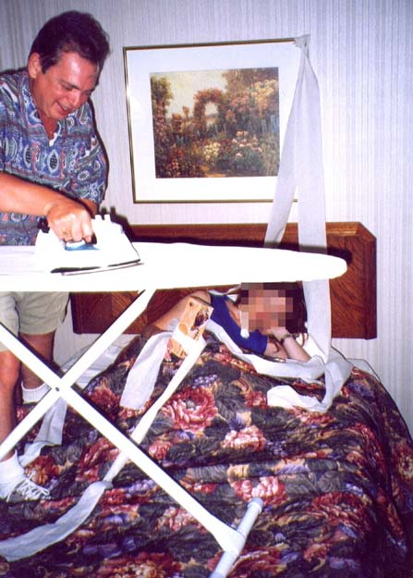
Liketh thou watching players under the stars? Evening picnics upon yon beautiful estate? Bloomington, Illinois? If thou answer yesth, then come partake of the Second Annual Weekend With Wm. (as in William, as in Shakespeare.)
As we did last year, a troupe of folk is heading to Bloomington for the Illinois Shakespeare Festival. It’s a fun group, great plays and a zany get-away overall.

Weekend III | Waterpark!

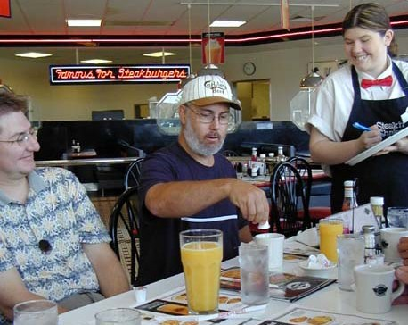
10) Let’s set up by the fallen tree.
(John’s suggestion, rejected silently, daily)
9) Oh, damn straight, Gary’s going to hear about this.
(Gary, President of Steak and Shake USA, wanted to hear our printed clearly comments.)
8) Everyone’s afraid of the aspic.
(Webster’s: “A clear jelly typically made of stock and gelatin and used as a glaze or garnish or to make a mold of meat, fish, or vegetables.” Us: The goo on the stilchester. Spoken around 2:30 a.m. in Room 214.)
7) Sans moo.
(All the world’s a Steak and Shake. As Elizabeth liked it, her coffee was without cream.)
6) Faux Pho.
(What they would make at the Vietnamese diner downtown if they ran out of the real thing.)
5) Stew reminds me of soup.
(At the Vietnamese diner downtown. Context unclear.)
4) My what a pretentious bag of cheese. And look what she’s carrying.
(Bryan with the set up, Deb with the punchline.)
3) You don’t have to go around, Ed. You have a Yukon.
(Advice from Elizabeth to Ed, in response to the recognition that a lawn separated the current from a desired location.)
2) They’re where the beach towels used to be.
(Question from Deb Dicke: “Excuse me” -- asked at the Target whilst attempting to accouter ourselves with swimming finery -- “but can you tell me where the swimsuits are?")
1) Excuse me, but I didn’t order the falafel.
(Or mayhap these be so-called “hash browns” referenced in the menu of victuals. {Spoken while breaking fast at the Steak and Shake.)

Captain Spaulding/African explorer says (from Uncle Tom’s Pancake House):
10) Why is my tomato juice bubbly?
9) My orange juice is too.
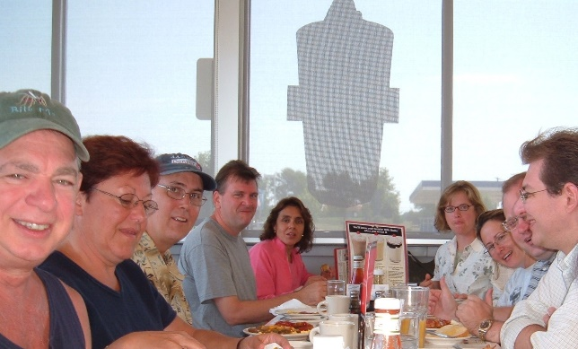
8) It’s fermented!
7) My pancakes taste like baking soda.
6) Waitress!
5) Would you like another, sir.
4) This coffee tastes like it is from used grounds.
3) I’m still hungry, what else can we order?
2) Next year: Where do you want to go for breakfast?
1) Uncle Tom’s is close.

Weekend IV | Grady’s Triple Cripple
Bumper boats, go-carts and mini-golf at Grady’s Triple Cripple Fun Park | Hamlet | Party at the ‘Best’ Western
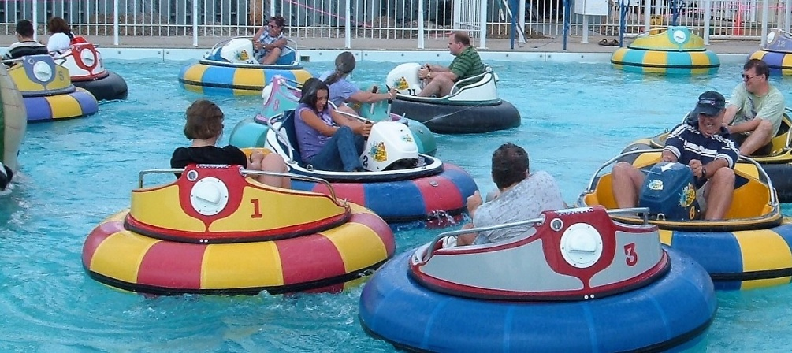
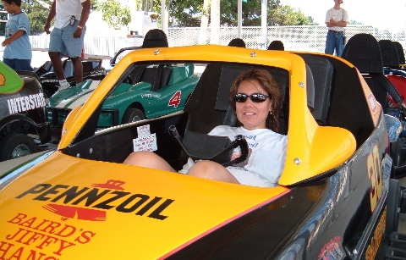
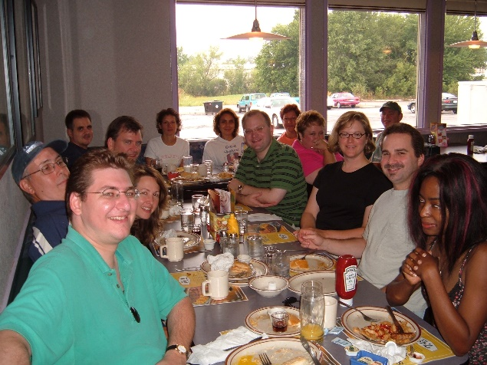
Weekend V | Ewww Lake Evergreen

Oh Shakespeare Where Art Thou?
An Ode to the Fest in Four Parts
There’s a Western we know, not the best
Which we visited each year at the fest
They took us for granted
We became disenchanted
Now Country Inn is the place that we rest.
We ate breakfast at Denny’s this time
The food was simply sublime!
They serve a Grand Slam
Cakes, hashbrowns and ham
Uncle Tom’s is more famous for slime
Grady’s was the site of our play day
The Eighties were clearly its heyday
We declared war
On poor Steve on the shore
Mateys, it was more than just an OK day
Kurt’s favorite is Cornholioanus
Since then all he does is complainus
He said of King Lear
It’s the same every year
I left him at home. What a painus.
– Kurt and Deb Dicke
Lake Evergreen
By the shores of the opaque lake
Thinking swimming in it a mistake.
Don’t open your eyes
Or so you might die.
Hey John stop throwing grapes.
– Bill Douglas
The Accidental Bryku
(On Reaching To a Napkin)
Looks like Bryan is
Going for another Haik –
U – having a snack
– The collective

Untitled
Oh Jack Kerouac
You spin in your grave to think
This is now the Beat.
– Rob Douglas
Which Folio Malvolio?
Weekend With was
Once wicked
When winsome wenches
Walked with
Wacky William wonks
Willing, waiting
Wondering when
Wouldst windward
Washboards wend
Wicker
Whatchamacallits.
William.
Shakes spear.
Throws spear.
Ophelia pain.
– Mike Mikottis
Heat
It was very hot
Nary a breeze to be found
I thought I’d pass out.
– Bryan Schneider
E=mc2
Ophelia
Pain
Hamlet
Those eggs be
Montague
Let’s Make a deal
Capulet
Fly off in the wind
– Mike Mikottis

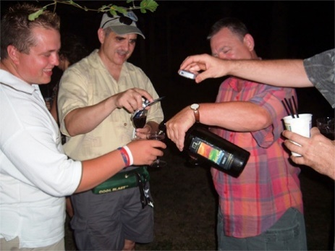
What Rhymes with Framboise?
Or, an Ode to Bloomington/Normal
(a/k/a the Reminder Sonnet)

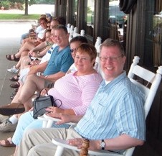
Shall I compare Weekend to a stilchester
In Illinois’ sun? It shan’t, methinks, stink
That much. Anon, then, friends, might I pester
Y’all – though ha-ha be our goal – upon the brink
Of our jaunt, remember these for thee:
Foods to bring and wine to taste, poetry we’ll
Slam. If caravan you’ll join, mail of e
To me please send. All else forget, till
Full on City Twin banquet we groan
(And from our hotel prob’ly out get thrown).
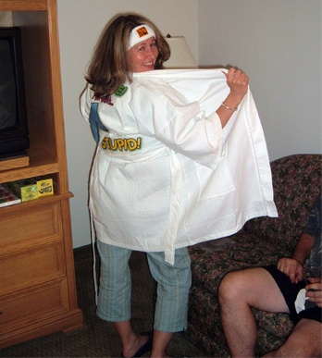
Trick Forks
Bryku Two, being a post-Weekend lament
on the ephemeral nature
of Pleasure, regretfully submitted
by YOS (Your Obedient Servant)
You salaam to cheese
O’erhead green breezed leaves snap now
You’re sporting salad
Untitled
Oh Malvolio
You are a crazy bastard
Nice yellow socks man
– author unknown
Top Tens
11) I’m not a huge coconut guy. | Hoffman.
10) I didn’t throw the wine at the wall. | It was all a misunderstanding.
9) Not only the poem … but the whole world makes sense. | Upon listening to Which Folio Malvolio?
8) I think they serve breakfast. | Reference unclear, but one suspects the result was not happy.
7) Hoffman: I think Springfield has been pooh-poohed. Schneider: I already poohed it.
6) Hence the name Lake Evergreen … This looks and smells like what’s at the bottom of a port-a-potty. We now know why they call it Lake Evergreen.
5) Observe him, for the love of mockery, for I know this letter will make a competitive idiot of him. | Twelfth Night, 2.5.16
4) Will the Laura Bush cookies make me dull and inflexible? | Probably, Linda, but your fav/unfav poll numbers will be great!
3) Uncle Herschel’s colitis was acting up. | Cracker Barrel offered ol’ Unc’s favorites for breakfast. The choice of Metamucil or Pepto-Bismol was at least appreciated.
2) The knorks never really took off. | Sporks, on the other hand …
1) My son is dead? | And the winner of the Sofia Coppola Unexpected Inflection award goes to …
And this late but classic entry: It doesn’t have to be funny to be good comedy | John Kieken
More quote whore testimonials
- I truly enjoyed hovering over the cheese buffet table.
- What goes on here stays here (for the most part)
- Let’s open another bottle of wine.
- You could easily spend thousands more and not have a better glow-in-the-dark experience.
- Fun fun fun, now where’s my pants?
Person I’ve come most to despise over the weekend and why
- Uncle Herschel
- Sharon – Obvious reasons (Ed. note: Most literary critics believe this entry to be meant satirically, pointing out that there is more than one Sharon and that these Sharons are delightful people.)
- Actor who played MacBeth.
- Mike – his knowledge of wines.
- Am I limited to only one?
- Bryan – bad case of self-loathing.
- That lady with the raffle ticket hat, because it’s a job I could have had.
- John Hoffman, the Tyrant
- Kurt Dicke, for not showing up.

Favorite boiled meat

- Barbacoa (cheek meat is the most tender) in a taco with onions and cilantro | Elizabeth
- Tongue | Deb
- Smoked butt | Rob
- Haddock
- Water buffalo
- Corned beef | Bryan
- The entirety of the Famous Dave’s menu | Steve
- Ball Park Franks – they plump when you cook ‘em | Mike
- Kielbasa

Weekend VI | Drink Contest / Tewkesberry Slushies
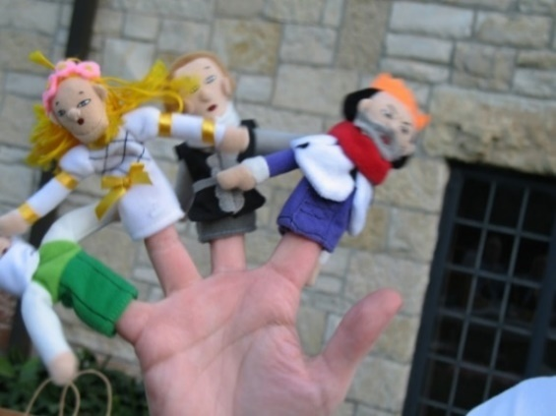
Bragging Wrights
Expectation laden I with weary writing tool fashion-conscious thoughts
Not too enlightened minds stimulation or pause
But soul leeward seeking only recognition
Again too Basque in past and future imagined glories
Beret cocked and goat tea drinking wino that I be
We bragging wrights of words and rites and rights
Pro and con test entering fools
Ripe now pick-me-up, up to heaven, pick me.
– Mike M.
Unnamed Fibonacci
1) rhyme
1) mood
2) not me
3) but structure
5) I can work with that
8) who really thinks the play’s the thing?
13) there’s one or two here. But they won’t admit it, will they?
21) of course it’s the good food, good drink, good friends and making a complete ass of yourself.
– K. Dicke

Who am I?
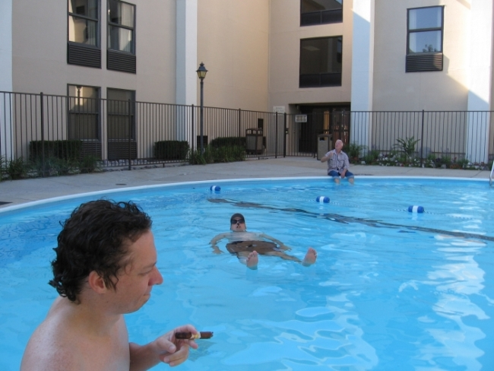
I was thinking just the other day
I’ve really come a long long way
Old Milwaukee and Cheetos were a treat
Jerry Springer’s show could not be beat
Then along came a guy named John
Who said come to Bloomington
Now it’s framboise and sheep’s milk cheese
And pooh poohing the choice of Pericles
– D. Dicke
Who are we?
John
Ed
Sharon
Mikottis
Bryan, Kurt, Debra
Oh, and another John and Sharon
And this guy that I don’t know that comes down tomorrow.
The Three Stages of Man

– D. Dicke

Beats Me
(A Somewhat Sonnet, on the occasion of Weekend With William, the Sixth of that name - YOS)
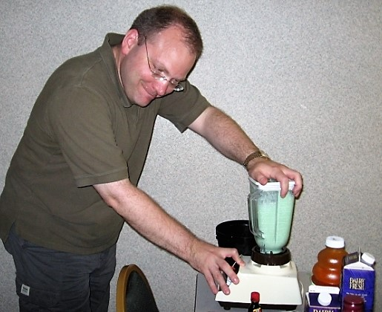
Begin the spin: Friends, blowhards, funny men, blend
Me a Rum Runner (extra rum). I come not
To praise us, but to mock. How is it we wend
From “wherefore”, “thine” and strange cross-gartered plot –
To glowing lake and Yukon shortcut? No beret
And snifter crowd, we. But, stink – what bag,
Pretentious, through yonder tub emits? To frappe
This mix of high and low sans reflex gag:
For best results, clump it all and hit puree.
We pulse and crumb, and liquefy Prosperos
Against the timbers of a Grady; or fold a
Faux Pho with Elizabethan heroes.
Can one great word totally explain us?
Methinks ‘tis this: Cornholioanus.

Unnamed Fibonacci
Me
You
Us Two
Yes We go
Plan, Do, and We
Everyone together having fun
Hoping and wishing for some [unreadable] do,
– Sharon II
The Brylenderku
[Sound of blender turned on and off, five times, then seven times, then five again.]
– Bryan
(Recipient, Grand Prize Rubber Chicken Award)
Untitled
I,
Yi,
Yi Yi,
I am the
Frito bandito
– presented by Kurt

Bryku
Who would have thunk it
A nice breeze at the Ewing
Wow that was quite nice
– Bryan
Weekend Top Ten, or Three, or Whatever
The Full Cleveland
Who isn’t an idiot?
Tewkesberry Slushies

Top Ten Reasons Why Weekend With William is Better Than A Trip To Europe
(Submitted by Weekender Mike)
10. Getting bombed means something different here
9. Don’t have to compete with ducks in Enlarged Liver contest
8. It’s $3972.00 cheaper
7. Two-and-a-half hours after you leave the house: Tarmac at O’Hare vs. Lawn Chair at Ewing Manor
6. Still Chester After All These Years
5. Deodorant
4. Hotel room keys fit in your wallet
3. If you forget something you can just drive back and get it.
2. Pretentious cheese comes with handy labels, in English
And the #1 reason…
1. Bring all the gel you want!

Weekend VII | Match Game 1675 / Pontoon Poltroons
Quote Whoring:
1. Shuck stoppin’ fun! (Steve)
2. I’d gladly give my right index finger for a boat drink! (Beth)
3. Please silence your plastic wine glasses during the performance (Beth)
4. Taking the “oo” out of Bloomington (YOS)
5. WwW: A world tour in pretentious cheeses (Beth)
6. 2 dog hairs away from paradise (Deb)
7. From iambic pentameter to haiku in one glorious evening. (Beth)
8. We’re mayoraly approved! (YOS)
9. I’m still discombobulated (John K)

Top Ten
Our Weekender studio audience was asked: Submit your Top Ten entries (quotes, events, memories, non-indictable offenses, etc.)
1. Millie stalking the rabbits.
– Please note: No rabbits were hurt or even caught mildly off guard during the filming of WwWm VII. Submitted by Steve.
2. “Is that Charles Nelson Reilly or Elton John?”
–Chris Hage upon seeing costumed Weekender Bryan. Submitted by Beth
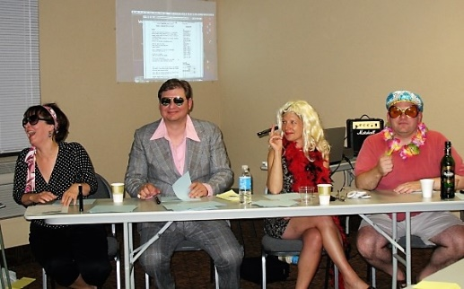
3. “I’m such an ass**** … Oh, I’m so drunk.”
– Quoth Mike. First stated around 6:07 p.m. at the marina and then again 38 more times for the next hour and a half. Submitted by John K.
4. “I know all about your kind of people.”
– Mrs. Dale Gribble. Submitted by YOS
5. Surviving the Cheney Presidency.
–Submitted by YOS
6. “I kind of went in a different direction.”
– Deb Dicke, as Brett Somers. Submitted by Beth
7. “Pace yourself; it’s going to be a long night.”
– Mary Jo. Was she talking to the room or to the guests down the hall? Or maybe to the nebbish desk clerk who eventually stuck half his head into the room at 2:30 a.m. and made gratuitous suggestions concerning volume levels. Submitted by Beth.
8. Erudite Juvenilism
– Steve’s characterization, for his mother Nora and Uncle Richard, of the spirit of Weekend. Hmmmm. It seems we may be oxymoronic. Perhaps without the oxy.
9. “I’ve got bubbles.”
– Bryan Schneider, as Charles Nelson Reilly. Submitted by Beth.
10. Mary Jo’s partial finger amputation
– Winner of both the first Weekend Purple Heart and the Funniest Bloopers Award. Submitted by Beth.
11. The GOP Breakfast Special.
– At the Garden of Paradise quote/unquote restaurant. No one ordered it, but presumably the eggs were past expiration, the sausage nearly rancid, and the nutritional content non-existent. In Illinois, one would expect waffles to be included, too, except the far right side of the plate, which would be rigid and filled with hate. Submitted by Beth.
12. “But you still haven’t told me where the dog was.”
– Mr. Dale Gribble. Submitted by Deb
13. “You gotta get what ya got comin’ out”
– John K. Deconstructing continues about context and meaning. However, consensus has magnetized around the theory that this was related to Steve’s comment above. See number 8. As this was spoken at Garden of Paradise, it also could have related to a dispenser of some kind. Recorded by Elizabeth.

Poems 2007

Untitled
Henry Five, a July night –
Although cool, a real delight!
Friendly folk, relaxed and loose
Thanks to Steve, I’m here “toose” –
Oh, oh, oh, before I go
Pontoon well, or next year no mo!
- Richard, I, Steve Kulm’s Uncle
Our Servant
Glory Be Our Servant John,
Who Shakes and Shakes and Shakes again
Till we all a“peare” in Bloomington
- Steve Kulm

Achin’ for an Agincourt
In a Springfield Mausoleum lies a man torn
For he does not know how to mourn,
For a Party whose next leader is not born
- Steve Kulm

Untitled

I’ve never been to Bloomington
But here I am, new friends and son
And brother, too, and dear old Will
My heart
My heart
My heart be still
- Nora Kulm

Bryku
Lost in Bloomington
Hungry as Bryan Schneider
Where’s the Taco Bell?
- Beth Hage

To New Lows
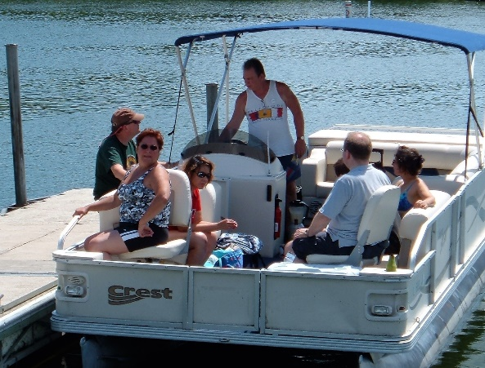
A Toasting Sonnet On the Occasion
of the Half Off Weekend

You meant well, Wm., we know. Yet: Oh, O!
The fault, dear artist, is not in your fine verse,
But sweat and wine do mix not well with BOH
Boh BOH boh BOH Boh BOH – and worse,

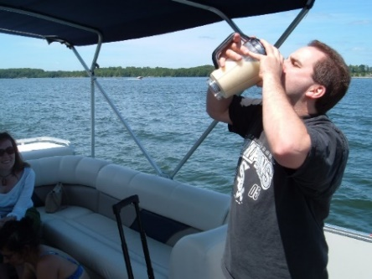
When adverbs, gerunds, subjects as shook soda
Do seem, and odd placed verbs are, juices sap,
Or tempest brains, which even follow Yoda
Not could, sink into a mid-summer’s nap.

Once more unto those seats, dear bard? My ass!
The thought of Love’s Labor Lost brings high panic.
Still: Mirth we’ll make; we’ll answers Match; we’ll sass
Ludqueeg on his personal Titanic.

So pistachio mustachioed, do
Vessels hoist now we: We few. We happy few.

- YOS
Untitled
Friday
(awaited anticipated)
(Amusing, Imbibing, Word
Rhyming)
(Balmy, dew-kissed, humid, sun scorched)
(nitpicking, nay saying, pancaking,)
(rumpled, bedraggled)
(Sunday)
- Deb
Song Entry from Beth
La dee dotti.
I like biscotti.
La dee dotti.
Dotti.

Untitled

Bryan
Charles Nelson Reilly
Paul Lynde
Bryan
Thurston Howell II
- John K
BRYKU (untitled although I had considered Man & His Blender)
Molto Bryan! The
mixologist supremo;
Le frappé savant.
- Elizabeth

Weekend VIII | River Tubes / Allen Ludden

Untitled RSVP
Dismal solitude.
Journey halted. Absent from
Weekender revel.
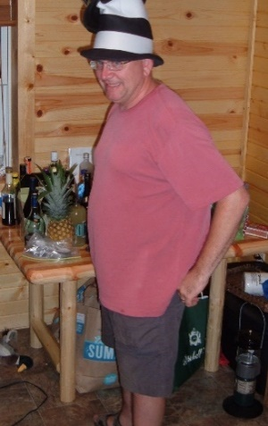
- Elizabeth
Wing-ed Angel
O, wing-ed Angel! Violin laden spirit
Play on- your lofty tunes!
Interpret for us your cryptic runes
Resist not my clamoring cries!
Speak to Ed, and those other guys.
- Mike
Here is my Haiku
Unfortunately it is
not all Bryku style
- Chris
Friku (unperformed)
Tomorrow looms large
A day of no play they say
Just hilarity
- Mike
I liked the play
I was hoping for witches
Maybe in 09
- Chris
Burn some Catholics
What is an armload of wood
That should keep us warm
[ALT last line: Who has some matches]
- Chris

Mineral Point! (Lyrics)
Mineral Point, Mineral Point…
What’s the point of you?
Mineral Point, Mineral Point… (It’s a)
Non-glaciated…
Slightly emaciated…
Unique point of view.
When the Password is “bucolic”
Mineral Point’s the clue!
When the birds in sky do frolic
Mineral Point’s the blue!
When it’s time to wax symbolic
There’s only one thing to do:
Raise Old Glory o’er Mineral Point
And give a hearty “moo"!
- Mike
__________
Oh, celestial orb
See how you shine above us
We adore your warmth
- Steve
Barack Obama
Meet the New Boss, oh really?
Same as the old boss
- Steve
__________
Frank Lloyd Wright is cool
Seventy bucks is too much
House on Rock is cheap
- Chris
Perhaps the Lady Doth’t Drooped Too Much
A Sonnet on Mid-Illinois Nights’ Dreams
Shall we compare Spring Green to
past loved site?
Warm corn-fed lips had she, a figure eight,
We thought. But o’er time a robust once-delight
Can almost seem somewhat – er – glaciate.

O! Summer joys we flung: Ewing dining,
B-Beer Nuts, cold Tewkesberry Slushies,
glow of lake,
The triple cripple who soaked us, whining
Of crummy breakfasts (except, ‘course,
Steak and Shake).
True, to have a Rubenesque figure here
May speak less of paintings than
the sandwiches:
But our hostess now, undulate land of beer,
Offers such voluptuous images.

Sure to Twin Town we hie again just might!
Till then: We’ll here, with that weirdo Frank
Lloyd Wright.
- Y.O.S.
Eee gads! Here I am with my subscription to
Elcastellano.org’s “La palabra
del día” expired! What can a woman do?
Oh yes Fibonacci can unite destra,
Sinistra; exalt senses like flights of wine.
Process mapping, budgets, yield no such extra
Delights of pretentious cheeses; words sublime!
Does she submit? Tolerate the daily hell?
When oh how she has yearned for this special time
Away from co-workers she can never tell.
Desesperación crushing soul. The pains!
Shakespeare! Merengue! Sheer joy they would compel!
Her wish for safe travels is all that remains
And next years’ hope for perhaps tidy quatrains.
- Elizabeth
Feet of Angels Bryku
Limburger is made
From BO bacteria
Ew, smell my fingers!
- Deb
do I entice you?
My quiet seething visage
One fit per trip. Done!
- Melissa
Life comes at you fast
Smell the roses, see the world
The slow lane is good
- Steve
Oh slug bug slug bug
Thin excuse to throw a punch
So satisfying
- Melissa
A last …
P eople getting together
O r
E veryone going it alone
M akes no difference, always a good time!!!
- Sharon
I can not compete
Deb, John, Bryan, Mike, Amy.
My poem is complete
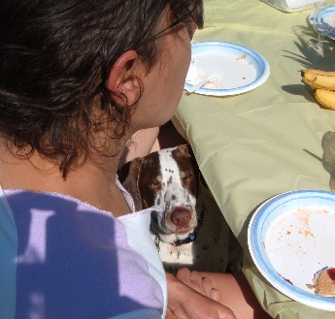
--
Know dogs allowed
Know dogs quiet
Who’s a good boy?
You are.
(don’t count - there’s no numbers associated)
- Mary Jo
Bavarian Inn
Lasses in dirndls and chucks
Plastic shoes of beer
- Melissa
Mineral Point
Bastard hills of drift less beauty
hoodwink pilgrims sleepy stupor
simple syrup drains trickling
coils of hidden streams
Herbaceous comforter of mud and flies
without urbane clockworks to spoil
dinner and slow justice within
a sip of water and savory bite
The ayes glaze over night frozen
and shattered tortoise shells
forgotten belie a lost love
hidden among dust and books
White haired ladies we all
we searchers mock carelessly
at our own expense really
glad for companionship
another year a better year
an earlier year for sure
Cornish fields and laborers well spent
have left their marks for us to find
Clay and old smells lift
in breathing humid waves
unseen mites of knowing caught
between glances and waiting
too late now to change places
embracing rhythm instead
moving in predictable order away
from home to home
- Mike
_________

Intimations of Inanity from Recollections of Bloomington-Normal
What though the gleam of Lake Clinton
Be now forever taken from my sight,
Though nothing can bring back the hour
Of splendor in the mini-golf artificial turf, of glory in the Ewing Manor bower,
We will grieve not, rather find
Strength in what remains behind,
In the oppressive humidity of outdoor theater,
Which having been must ever be,
In the soothing smears of pungent cheese that
spring
From Wrightian cows of single color,
In the faith that looks through intermission,
In the years that bring the alcoholic mind.
Thanks to the poets heart by which we live,
Thanks to its meters, iambic or otherwise,
To me the mixedest metaphor can give
Thoughts that lie too thick for tears.
- Bryan
__________
Top Ten (and Runners Up)
11) “Come on, everybody, we appear to be in a big hurry.” (Amy gets some backsass after trying to move our tubes downstream instead of sideways.)
12) “Looks like seventeen years of vegetarianism out the window.” (Yes, Beth, Sharon’s “tuna” salad will do that to you.)
13) Robert the Doll. (It is critical with this one to enunciate in a Hagean baritone.)
14) “Peaseblossom!” (Mike liked saying that, a lot, with corresponding flourish.)
15) “Can I get a bit of the Kurosawa?” (Requesting a favorite soundtrack from Beth’s 50-cent plastic flute.)
16) “Yeah, I used to care.” (Deb’s assertion.)
17) “Well, I must have had someone in the bar this morning who worked at a cheese factory.” (Waitress at Puempel’s, after Bryan’s discourse on the bacterial relation between limburger and body odor.)
18) “Shine on, shine on Sturgeony Moon … !”
19) “Make historical markers part of your lifestyle.”
20) “Oh, just get an armload of food.” (Instructions to Bryan on his way to buy fixin’s for breakfast.)
10) “Oh, is there paperwork to fill out?” (Melissa, on seeing Top Ten entry forms being completed.)
9) Do dogs pee in the water while they’re swimming – or poop, for that matter? … Good boy, Lenny! Good boy! … No, downstream, downstream! … Oh, that’s just nasty. (The final comment from Hage.)
8) “Oft won, never washed.” (Ed’s troubling observation on the GoH.)
7) “Is that Homeric or classical Greek?” (Bryan, binoculars in hand, being queried about the words on the prop Port-O-John on stage.)
6) What exactly is the definition of ‘armload’? (An Ed-xistential question, from the unit of measure that firewood is sold by at the resort. Many advanced degrees never found a satisfactory conclusion.)
5) “Going to hell in a Rachel Ray Waste Bowl.” (Bryan, updating a classic.)
4) “Screw you guys; I’m getting on that canoe.” (Sayeth Deb during our strung-together tube tour, referring to the offer she received from a passing and presumably more handsome group.)
3) Pay showers – cleanliness costs. (But it’s the best eight-bit hosing off you’ll ever buy.)
2) “Aris-toph-anes?!” (Bryan’s dramatic reading while docenting the Allen Ludden Papers tour.)
1) “Don’t f*%# a whore without a condom, and don’t put your purse in a urinal.” (Hage’s proposed solution to 80 percent of the nation’s public health issues.)
A Weekender’s Thanksgiving
(A post-Weekend ode)
As we rinse the algae from our swimsuit
crotches
As we dig the rich Wisconsin earth out from
under our toenails
As we scrub the smell of Limburger from
our fingertips
Let us give thanks.

For armloads and blenders, Fibonaccis and
FIBs*
For spacious bathrooms that are not steamy
For vodka gimlets and stagnant tubes, liverwurst
and young coconuts
For sitcom Shakespeare amidst monochromatic
cows
Oh, let us rejoice in Aristophanes and also the
sublime
And the look of childlike wonder as a new
GoH owner is born

But most of all, dear weekenders, let us be truly
grateful
That we are John Hoffman Family and Friends.
Amen.
*F%#@!king Illinois B@#$#ards
- Deb (Malvolian of the Year)

Weekend IX | Weekend Olympiad / The Lodge
William Weekend in Wisconsin
For not faint hearted
Lacerated toe in Moccasin
Gangrene hath started
- Scott
_____
I Hate Haikus
I hate haikus lots
Stupid little pointless things
Wait I just did one
- Alex
______
Gownku (courtesy FTD)
For the gown winner
Prancing and dancing with glee
Welcome to the fold
- Melissa
______
William Weekend Nine
William Weekend Nine
Exposed to William first time
Cover my ta-ta’s
- Andrea
______

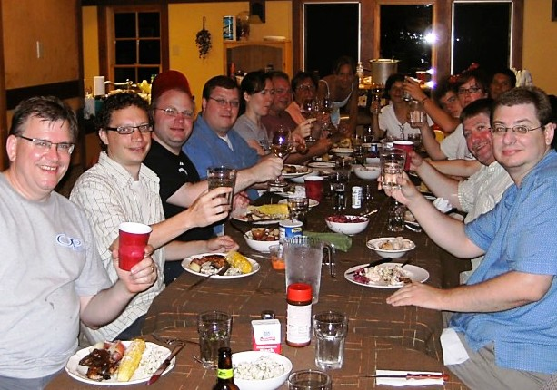
A Bovine Fantasia
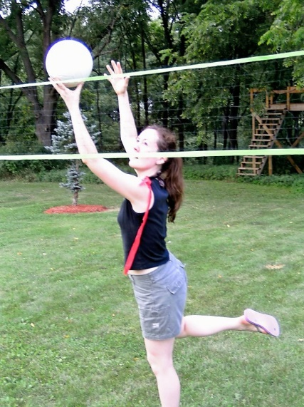
How now, cow
You are brown
Or black
Or even moo of blue
There is no variegation
In your pigmentation
Your single hue
Is pleasing to the eye
Standing stark against the sky
You, rumen true,
Do but chew
Converting grass of green
To nectar white
Which passes then to local cheeseries
Where Kelly, of hair color light,
Does regale with tales of muenster, swiss and cheddars all
Until we, few merry band,
Do pretentiously munch from mouth to hand.
- Bryan (Malvolian of the Year)

Lodge Sonnet: A Tete-a-tete Between Pheasants, One Worried, the Other Not
They’re blind! – squawked Fred’rick – gullet flushed of hope.
That walls that in iced days release their scent
Of slaught’rous beast should in summer not scope
Our urge to preen and plash. O joy is rent!
Hang on, says Murray. I seen this gaggle.
I heard ‘em come; you won’t believe their story.
We know rifle butts, but malmsey? A bag’ll
Cheer ‘em – if it’s got brie instead of quarry.
You see they brought no dogs? I heard one say
They couldn’t kennel theirs, not knowing whether
He’d feel lonely. When they say “game”, they mean play,
Not us! Brykus? Gowns? Don’t ruffle a feather.
Thus Fred’rick warbled odes: ’Tis this I wished!
Till he, by a misthrown water balloon, was squished.
- YOS

From our Customer Evaluation Form
Testimonial quote:
Weekend with William: As Seen on TV | Rosencrantz
It’s only once a year! | Mike
You can visit Wisconsin and leave your firearms at home. | Andrea
I’ve participated in Weekends of all kinds in my adult career. This sets the standard for William’s. Tour de force! | Deb
Who’s in charge of this chaos?
We are tramps for the trampoline | Steve
We made it to single digit | Bryan

For Weekend X, we should all be prepared to:
Take singing lessons! | Rosencrantz
Learn Roman numerals greater than 10. Or up our medication. | Deb
Reach out | Andrea
Learn what X means | Steve
Stay up late | Beth

Other thoughts/suggestions:
Inflatable doll – oh wait – I meant inflatable pool | Rosencrantz
Go to that Canadian one. | Mike
Ballroom dancing in the ballroom. | Andrea
More game shows; less games. | Beth

Unspeakable erotic fetish (this information will be kept strictly confidential):
See #5 | Rosencrantz (referring to “other thoughts” answer)
The soft flesh just below the last rib bone | Andrea
Well first order some shoes from Zappos. Then when the UPS man comes, I say “Thanks, see you soon!” Then I try them on with a bunch of other clothes I have in my closet. Then I get a Diet Coke and watch “Cake Boss.” | Deb
Midget orgy | Steve
And the Top Ten are –
1) Why can’t anyone make a decision? | Alex – so wise so young. From Deb.
2) You’re lucky I didn’t have my bare ass on that one. | Andrea, shortly after the sublime sound of a whoopee cushion echoed through the ballroom.
3) Is there an event for sucking? | Bryan. From Deb.
4) That’s not bug spray. It’s Easy Off Oven Cleaner. | Mike at APT. From Bryan
5) I believe in pleasure units! | Andrea
6) Guys, what about the swale!? | Safety Officer Andrea wants no twisted ankles. From John.
7) Chris you’re next. | Robert the Doll. From Beth
8) Seriously, you are going to have to stop that. | Chris, presumably supine and in near whisper, apparently not appreciating his 11:55a wake-up call courtesy of Alex, a microphone and an amplifier. From John.
9) Sure, I never mind a little Cockburn. | And variations of same. It is believed Scott introduced us to this game.
10) OK, let’s move the cheese out! | Mike
Weekend X | Clam Bake!
1) Q. You mean there are drinks that don’t have alcohol in them? A. Yes, those are called “mixers”. (Mike with the Q. Hage with the A.)
2) Bivalves don’t wear hats. (Chris deconstructing “Clam, I Am.” From Steve.)
3) I’ve been in your underwear for 15 minutes. (Mary Jo to brother John; a reference to the scavenger hunt, mind you. From Steve.)
4) Smell Cap Bone. (John Hoffman’s charades clue. Think: Infamous gangster. From Beth)
5) I picked up a clam with my sausage. (Said Kurt. From Beth.)
6) How many soldiers is that worth? (From Melissa, in regard to the GoH scavenger hunt)
7) I thought she had a good hand when she asked for one card, but then I remembered she doesn’t know how to play poker. (From Melissa.)
8) The Friday hat plethora. (From YOS)
9) Steve, please let some air into the vault. (From Melissa, said during our bank-turned-restaurant visit)
10) Kapanke for Kapongress. (Speculation by John, Mike and Bryan as to what might be the slogan of the Kapanke for Congress kampaign- question arising after seeing the yard signs scattered throughout the Lone Rock-Spring Green-Mineral Point corridor.) … Speculation that reason only last name is used on signs is due to an inconvenient full name, such as: Hank E. Kapanke. (From Mike.)
Other submissions …
C) I can see into your soul. (Robert the Doll quotation. From Beth.)
K) A chicken in every Ka-pot. (Another kapossibility. From Mike.)
L) Kapossible headline if campaign fails: Kapanke Kaput. (From Mike.)
____________
Untitled
Funny hats and masks
Pretend or reality?
Truth in the falsehood.
– S&M
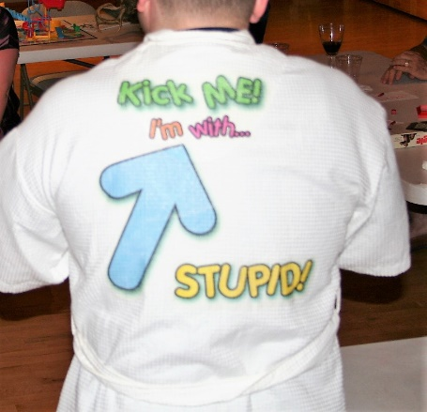
Pate Haiku
Canard in a can
melt-in-your mouth force fed duck
Don’t eat the cat food
___________________
Oft Worn, Never Washed *
An annotated ten-year walk through
Weekend wearing the GoH
And if what’s-been and laughs, like stilchester
Crumbs, affix themselves to you, this half score years?
A cloying framboise spot first will mess your
Markdown fibers. An iron burn by Ed. And there’s
Some cream from one weird udder. A cleaning
Now from Triple Cripple water; then muck –
Eww, yuck! Lake Evergreen, you suck. Careening,
A sprig hits from out the blender. What the …. Luck
Would have it: A hair or two off Milli.
Did those unnerving stains come from Rayburn
And from Ludden? At least swale smudged grass, willy
Nilly, is covering up your Cockburn.
Gown! Your blotched textile – but polyester –
Is our fine yarn, where, O Future Folly: Fester!
— Your Obedient Servant
* Disturbing title coined by Weekender Ed
Wily Willy Weekend
-Words and music by: Shakey Willy Wordsmith
(aka Muddy Mississippi Mike Mikottis)
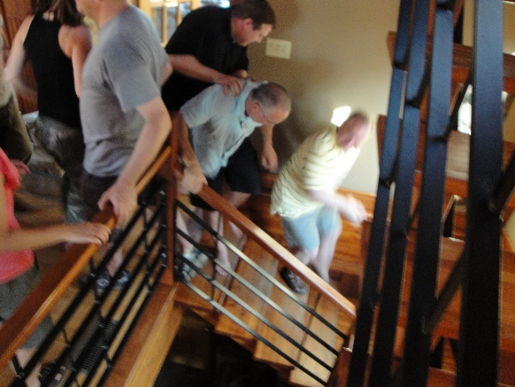
The Wily Willy Weekend
Willy stay, or will he go?
The written words we’re speakin’
We stole from him- don’t you know?
Come for the cabin fever
Maybe stay to see the show
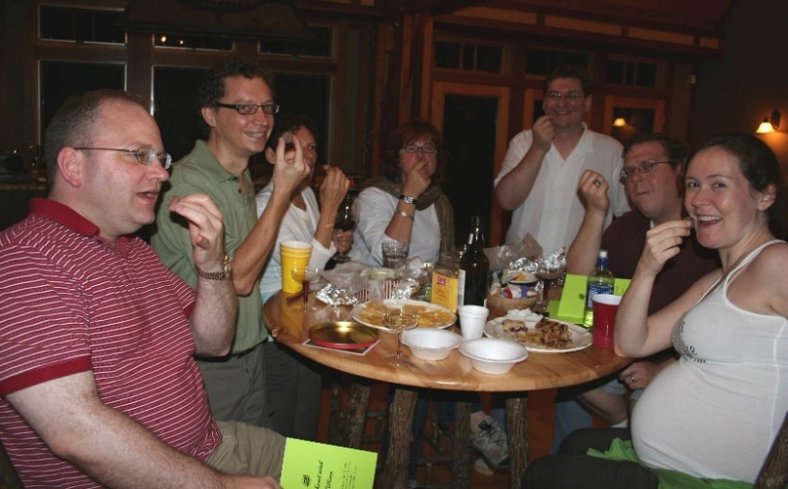
The Wily Willy Weekend
We just say the things the play
But it’s more a stage we’re going through
Playing here on this fine day
Hard to say just what is Normal
Until you’ve been there for two days
The Wily Willy Weekend
In the cauldron boil and bake
Cobby corn and clammy taters
In the embered whole we make
Discontent made glorious summer
We ourselves are at the stake
____________________
Meow
Wally the Brat Cat
Oh! Jump in that kitchen sink
Meow of Triumph
– S&M
___________________
Try Real Hard Not to Be a Jerk
-Words and music by: Shakey Willy Wordsmith
(aka Muddy Mississippi Mike Mikottis)
instrumental opening
Try real hard not to be a jerk
Try real hard not to be a jerk
It may look easy but it’s alot of work
Try real hard not to be a jerk
instrumental finish
Weekend XI | Family Game Night
Weekenders were asked to offer “quote-whore ejaculations” as a testimonial for Ww/Wm.
How can you not have a blender? (Elizabeth Herrera)
There are lots of neato animal deads and stuff. Plus lots of doors to open and close (Isaac Hage)
I was nice to Robert. That’s my story, and I’m sticking to it. (Abby)
Sexy, shirtless men on tractors will greet you at the gate. #yum (Jaime)
You’ll like the cut of our jibs.
Question of the Year: Most unsettling odor and suspected source.
Chinese vile slop liquor from Deb (Fujushan) … Mary Jo
The anti-freeze Deb tried to get me to drink #notcool … Jaime
Something the real baby did … Jaime
A baby isn’t really bothered by smelz … maybe something in my dipey? … Isaac
Sludge tank at the Living Waters Project at the cheese factory in Plain. Source: Recycled cheese, water and byproducts, microbes, plants, roots, etc … Elizabeth

The Tops
(A) Shhhhh! | An especially snobby and bossy crane foundation visitor, with her advice to a Weekender contingent. From Elizabeth
(B) I will go to bed and cease to be your entertainment. | Chris in the center of the smoking rotunda, just after being awakened by the laughter that followed a sleep nod. From Elizabeth.
(C) It’s like looking at the dead popes. | Bryan and/or Mike, upon viewing the microbrewery in the basement through the floor windows of the Corner Pub/Bakery/Brewery. From Elizabeth
(D) A baby likes the beach that allowz daddy to have special drinkz | From Isaac Hage
(E) “Isaac, you are a handsome baby.” | Said almost everybody. From Isaac
(F) Baaaa — goats head over the fireplace | From Isaac
(G) If cranes are on your bucket list, check it off now. | Quoth Bryan
(H) I don’t think a horse is an ungulate. | Said Chris
(I) Listen, sha-rew!
(J) Don’t worry, I’m not looking at your wife’s ass … even though it’s in my face. | John to Chris. We were playing Twister. From Jaime
(K) Kris Humphries lookalike in the play. | From Abby
(L) The shrimp. | From Abby
(M) Silly bands. | From Abby
(N) Now, what’s the rules to the game? | The universal question for retro game night. The secret answer was: Huh, rules? From Mary Jo.
(O) “The one problem is that the oven’s been leaking gas from a lot of different places.” | An admonition we received after the kitchen remodeling.

Kulm Kocktail Kontest
We have yet another new tradition: The annual, traveling Kulm Kocktail Trophy ….. Congratulations to Weekender Chris, the Kulm Kup laureate! And many thanks to the Kulms for the trophy and concept.
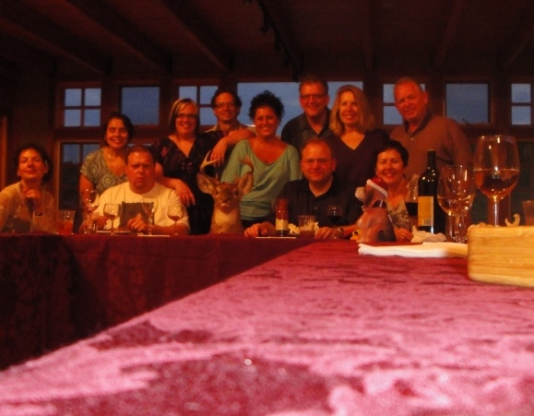
_________________
Strawberry Basil Lemonade Cocktail
(all measurements are guesstimates…)
- 2 shots Rum
- 3 large strawberries, cut up or pureed
- 3-5 basil leaves
- Lemonade
- Ice

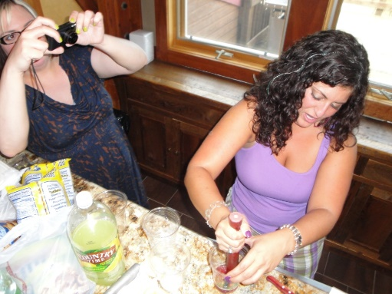
(I would recommend in your standard pint glass)
Muddle rum, strawberries, and basil.
Fill glass with ice.
Fill with lemonade.
DRINK! (From Abby)
________________
Raspberry Mojito
(again, disclaimer on guesstimates)
- 2 shots rum (the WI liquor store didn’t have raspberry flavored rum but that makes it even better)
- 5 red raspberries
- 5-7 mint leaves
- Sprite/7-Up/Sierra Mist (whatever your preference)
- Ice

Muddle rum, raspberries, mint leaves.
Fill glass with ice (again, I say pint glass)
Fill with the lemon-lime soda of your choice.
DRINK! (From Abby)

Gin Blizz (aka the Gin Shake-Up)*
- 2 ounces gin
- 1 ounce lemonade
- 1 big tablespoon bar sugar with foamer
- Ice (plenty of)
Blend it all together, or if necessary, shake. Great for beach parties and as a substitute for a morning glass of grapefruit juice. (From YOS)
* Propeller beenie tip to Weekender Beth for the State Fair-esque alternate name. And even bigger hat tip to Beth for coming up with the Kontest in the first place.
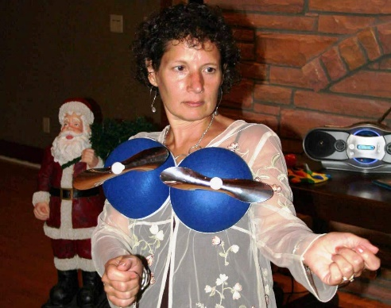
Some Haikus
Elizabeth: Nice!
From Flor’da. Really likes us?
We’re Sally Field!
Elizabethan
Sonnet: What I planned to write.
But then, uhk, nothing.
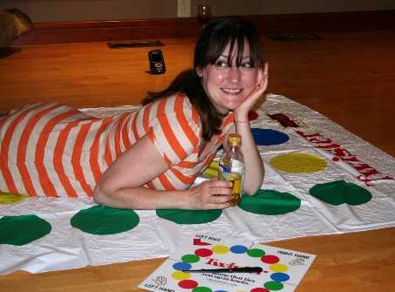
Couplets, iambs, feet,
Rhyme schemes. Hell, I’d rather climb
Kilimanjaro
— YOS
______________
Remembrance and Reminder: A Post-End Note
As the cow said to his mom, Thanks for the mammaries
This ‘postend’ I am not up for poetizing,
To meter muddle our happy dregs: Peels
Triumphant, sand dragged home, gobs of Visine,
games put back, new blender packed, cigar butts, wheels
Of pretension Ziplocked – Again, jerkily,
Our Gown on hanger-new awaits. One crew
saw all cranes and sniffed cheese sludge. And our whole troupe, we –
Some small, and from far, those new, one sha-rew –
In warm days quaffed, put tongue to Mikotti
Surfeit, and snacks … And now, for future smirks,
Please hit the blogs, post your pix, and all try
To soberly record how your drink works.
But more verse? William, see the end of my fist?
I would rather head to a taxidermist.
— YOS
Weekend XII | The Twisted Olive Supper Club / Canoes
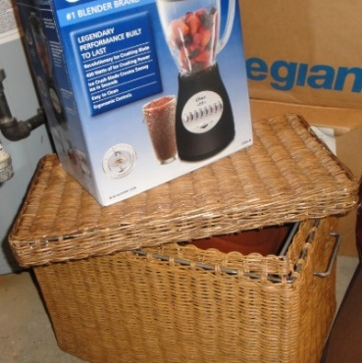
Lacking
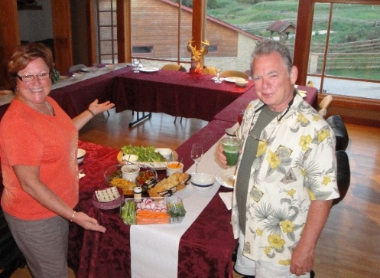
No poems. No Bill.
No Brie.
No Dickes. No Kurt
No Me.
Some boozing.
Some gazing.
Some tubing.
Some grazing.
But,
No pretense. No plays.
And,
No me.
. DD
_________________

Being Pickled
A sonnet toast to the grand opening of The Twisted Olive Supper Club
The heedless space of a bulbous Chevy
Encases them. Find a spot. They see the host.
Two gimlets to start, drained clean as Evvie
Lowers oil-basked meats. More drinks. They toast,
Lost in cackles and haze and paneled murk
And highballs; an extra plate for bones – “Daddy,
Lookit me!” – A drop-by from Ern (and wife) from work,
And heavy creamed drinks near the silver dressing caddy.
The building’s a kind of warehouse today.
The drop-ceiling’s sallowed. Waste oil out back.
Corrosion, from gin and smokes, has its way.
But mostly time. (In us, years find a snack.)
Yet – in prudent cars – we came: To* their spirits,
This moment, shining fresh as relish-tray carrots!
* All, please lift glasses here. This is the time of the toast you lift your glass.

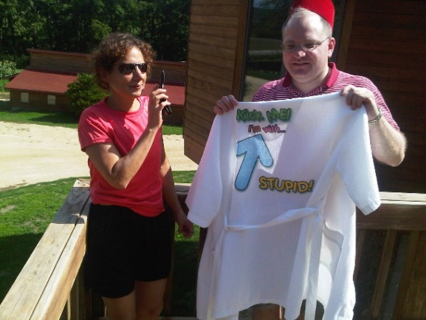
Fully stocked sand bar
Our first hai-canoe
A Triumph of Intercontinental
Communication
Driftless flotilla.
Trestle? Ed we’re tipping we’re —
Phones in white-rice bag
— YOS
Top Tens
A) You can ferment almost anything | Mike. Noted most every year past, too.
B) I think I just prevented cancer for the rest of my life. | Chris, after burying his head into Mike’s giant bag of greens
C) Is this our pie? | Chris
Whose f***ing pie do you think it is? Do you think people just drive around Wisconsin dropping off pies? | Mike
Yes. | Chris
D) I should probably put the scissors down. | John
E) Ohhh … Frank Lloyd Wright | Ralph, as Tom’s anti-Mies t-shirt becomes the final clue to solve the porkpie hat, cape and walking stick costumery
F) It’s not emasculatingly pink. | Bryan, referring to a rose wine
G) It looks like this is the big sandbar on the map, which means we’re already about 40% done. The trestle’s probably right around that bend. | John, off. Way. But the big sand bar at this point becomes a fully stocked one for the next overconfident hour.
H) When I think of our flotilla, I think of ‘aerodynamic.’ | Beth
I) No one’s looking. | Mike, while John finds his level in the river after several upstream carafe tips. Blazizzle-filled-carafe tips, to be precise
J) I am. | Anonymous nearby canoer. See “I” above.
K) I really enjoyed the canoe trip. | Bryan, the last Weekender one would have expected to and the only Weekender who did deploy this sentence.
L) The Bataan Death Canoe. | Chris
M) Technically we did not capsize. | Ed
N) That was very good Blazizzle. | Beth. See recipes blog
O) He’s lying. | Beth, after Chris has gotten four and a half words into our tale of bumping into Bob Riverside at the convenience store
P) Oh cabin, my cabin. | Mike. Whitman’s first draft
Q) You’ve never been in a cenote? | Chris, pulling out the marker for a cross-section and birds-eye rendering
R) Good lord, man, give your physiology a little credit. | John’s advice to an impatient Mike as our eyes adjusted to the night. From Bryan
S) Great hike. Just look out for the aggressive darting Wisconsin king cobras. | Bryan
T) I thought if I had the DTs, that’s what it would look like. | Beth referring to House on the Rock
U) How could you run a golf course, and yet, fill up eight buildings with crap? | Chris referring to same
V) It cooks with protons. | Mike on the odd lodge microwave
W) Rice-a-phoney. | John
X) Come again | Sign on the Don Q Inn door, which, after going through the creepy tunnel and hall of barber chairs, seemed less a friendly suggestion by the proprietors and more our own puzzled questioning.
Y) You are too small for this interior space. | Bryan as FLLW, walking stick pointed at a befuddled Weekender Ike
What sustained Weekend XII …

Guavaberry Boat Drink* | Beth

Motto: “Don’t let the taste fool you; old man Guavaberry will punch you in the face!”

- 1 shot Metaxa
- 0.5 shot Guavaberry
- 4 shots OJ
- 0.5 shot grenadine
Fill tall glasses with ice, pour drink in glasses, and add a celery leaf garnish

* By popular acclamation (i.e. most calls for more batches), winner of the Kulm Kocktail Kontest
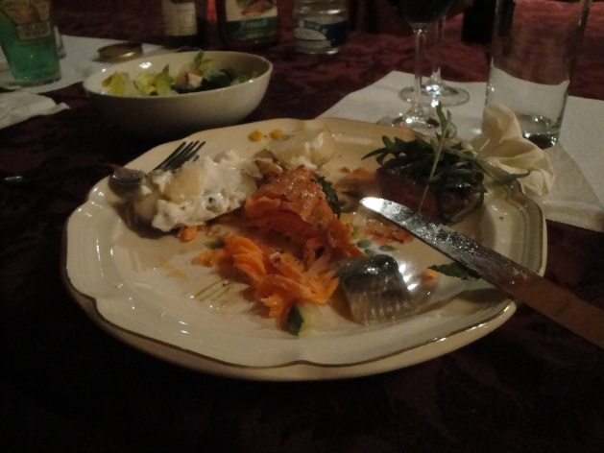

Gin Blazizzle | YOS
An updated version of last year’s entry:

- 1 part gin
- 2 parts lemonade
- Lots of ice
- Muddled basil

Shake or blend. For best results, drink several.

Canoe Sunburn | Chris

Motto: “After 5 hours marooned in a canoe, you need a whole pitcher!”
- Fill blender with watermelon
- Pour malibu rum to a count of 5 (about 1/4 bottle)
- Pour Midori to a count of 2
- Pour grenadine to a count of 2
- Add two scoops of ice
- Blend
- Garnish with cubes or slices of melon

Weekend XIII | Our Old Timey Picnic
Weekenders —
For those of us who need structure to our lives, here’s the rough outline for how we will enjoy ourselves:
Friday, August 23.
- Arrive at the lodge in the afternoon.
- Dinner at The Bank … Yes, it’s reopened!
- Play (8p)
Saturday, August 24
- Morning. School of Picnic (Prepare and learn to prepare a first-class picnic)
- Noonish. Mess around. (Governor Dodge? Road Trip?)
- 4pm-ish. Cheese and cocktails
- 6pm-ish. Let the picnicking begin … Games, fun, and possibly more.
-----
Kulm Kocktail Kontest winner XIII: Beth. Not even close
This came in a distant second: Whiskey Blazizzle. Lemon juice, sugar, whiskey, basil. (See last year’s entry for rough portions)
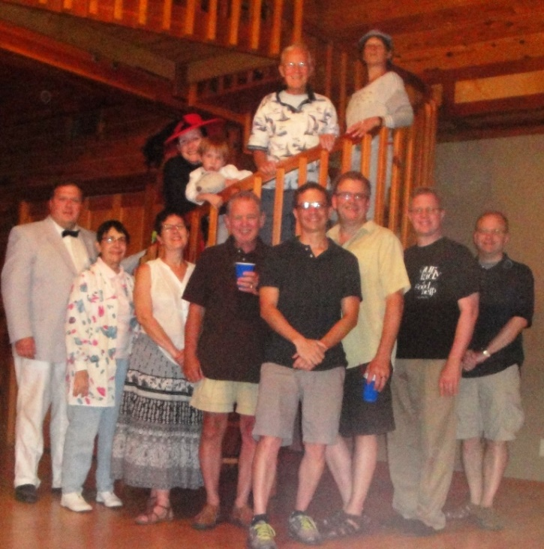
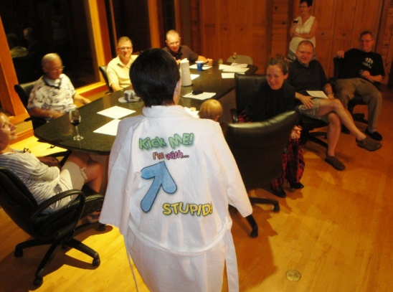
Weekend XIV | Burr House / Victorian Game Night
The year we learned of the new charms of our old friend Bloomington. Beth once again killed with her Kulm Kocktail Kontest winner. We found the hidden gems of the Mackinaw Winery, Lucca pizza, an Art Deco church and one of the best performances we’ve ever seen. Congratulations GoH winner Chris Hage.
Top Tens
- That killed in Spring Green. | Our attempts to entertain at the Ewing Estate ended with mixed results. DD
- A Dither in Burr House. | Deb’s suggested title for the book version of our jaunt.
- Mary Ann still needs to talk with you. | Surly lodge owner not happy with his guests. Deb thankfully averted the lecture.
- Burrrr House is a very very very old house (old house!) … Paint peeling off the walls. Dust bunnies in the halls … With two guys in the yard. Not working very hard … With mold spores in the rugs, look out for those bed bugs. | Apologies to CSNY. The Collective.
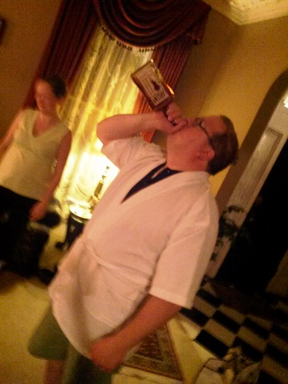
- Thus Blows the Grand Seigneur. | Those Victorians sure knew how to use a parlour. As well as a bag of floor and laps.
- I just dinglebelled my shorts. | The dangers of removing a jester hat while holding a glass of wine. JH
- I won’t poop until Thursday. | Yes, Deb did bring lots of great cheeses. MJ
- The petulant jester.
- They need to be de-muffed. | MJM2
- Bioluminescence! … No paparazzi! | Quoth the pre-four-year-old. Ike
- Griffin!! | The uncanny Hage charades mind meld
- The Pazzi Conspiracy did not include Ralph Malph. | Bryan
- Chris: I’m going to go put on some pants.
Mike: Please.
- I’m sorry for terrifying you. | Woman at park after remotely unlocking her car while we walked by.
- Looks good ... | Burr House owner’s announcement upon bringing out breakfast: Was never clear if she intended an exclamation point or a question mark.
Weekend XV | Vaudeville Murder Mystery
The Weekend Wrap-Up:
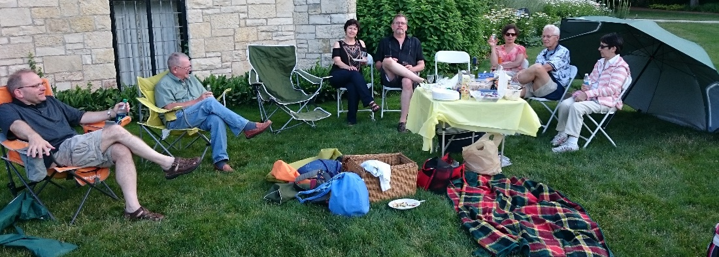
The King paid us an audience before tossing on his robes. Next day we costumed ourselves, according to the mind of Bard of Bloomington Deb “Murder She Wrote” Dicke.
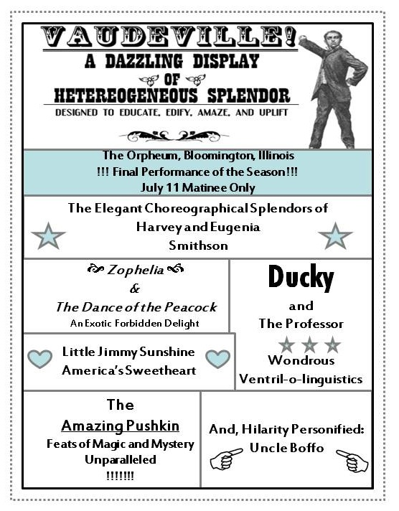
We quaffed wine at an art fair, rode silly bikes, lied our way through to a new GoH winner (humility virgin Wayne), charaded like Wizards and had the best Turkish food this side of Constantinople.
And for the record, Kulm Kocktail Kontest winner: Chris Hage, Dark and Stormies.
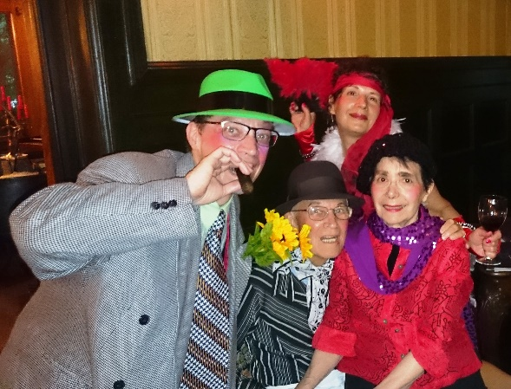
All amid the splendor of a real-life, top-hat-displaying mansion with sublime breakfasts that offered no melons but the grand lemondrop.

Who and how done it: Weekend XV
The Time-to-Vote Sonnet
It wasn’t Mrs. Vrooman’s sturdy bread
Or ghosts of imitated Lincoln trees.
We didn’t end up under wordy head-
stones because of bitty bikes that kink the knees.
The Butcher of Bloomington: Acquitted.
So too the Ace of Pomeranian.
Towanda round hurt no one. We flitted
To Normal and lived to tell the tale again.
And now we know everyone playing
Did no offing (except the faux Commie).
So who of us is guilty of a slaying?
Vote your Top Tens now. Choose one from Tommye
Or another. For on a mansion knoll,
It was we killed us – wielding only a droll.
Top Ten
- “When Pushkin comes to shovekin.” | Mike (submission: Beth)
- “Why did you come here? … Towanda around.” | Tommye (submission: Deb)
- “Do you remember what card you were dealt?” | Mike. Was that a catch-the-liar question or not or both?
- “All at the same time?” | Tommye after our server went through the exhaustive list of possible burger condiments at Kick’s in Towanda.
- “Do you like Mike Mikottis?” | John Hoffman trying to winnow out the one holding the Ace of Pomeranians. (submission: Deb)
- Head cut off gesture, pop off head motion, put on platter, offer | Deb’s Salome charade (submission: YOS)
- “In 50 years I’ve never seen a duplicate, Ed.” | Said prior to the first of three charade Ozes
- Williams Bay — MJ, with the impossible guessing game.
- “Oh dear, here comes Mrs. Vrooman with her loaf cart.” | The Queen, despite her better judgment, commands me …
- The Lobster Lover’s Lament (Genre: Country/Western). “The window shades are drawn, my wife’s face is drawn, the bank man says my account is OVER-drawn. But my butter ain’t hardly drawn at all. What’s a man to dip his two-tined fork in?”
- “Nothing with a tail or a foot” | Bryan’s wine buying guide
- “Everyone knows we’re wending.”
- “They call me the Butcher of Bloomington.” | Richard II, aka the artistic director.
- “This replica plaque honoring that replacement tree …”
Weekend XVI | Beverly Hillbillies Mystery Night
Once again unto the Vroom, dear friends. Some highlights:
- Newbies Fran and The Johnbon (half newbie, at least) seemed to like us. We felt very much the same. They’re in!
- We were shocked/shocked to discover Weekender Tommye, aka Emily Pennyfeather, capable of murder.
- GoH winner MJ taught us of Grecian urns, while we came to understand so much more about each other’s talents.
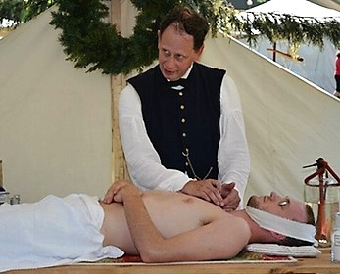
- Cantaloupe sorbet.
- We hosted our first virtual Weekenders, Beth, Ike, Chris and Cora. (Next year, we shall drag them from California if necessary.)
- Lincoln rabbit eared us. (And appropriately, we learned: (1) The Republican Party of Illinois was born in Bloomington and (2) Civil War embalming techniques.)
- Most critically, we realized (via Weekender Tommye): Why in the snot should we drag everything to the Ewing grounds when we can dine on our own mansion veranda?
Top Tens
- You don't even have to have a line to be a bad actor. | Mike M, speaking of the skittish bit players.
- This Indignation Meeting is hereby called to order. | We learned that when people felt irked in the 1800s, they got together and whined. We intend to revive the tradition.
- The Johnbon. | Our new Weekend celebrity couple.
- I feel like I’ve been put in a bowl. | Chris Hage through FaceTime. He was right. But oh what a fancy Vrooman bowl.
- It's rude to do email at the table. | Bonnie to Fran, after we encouraged her to take out her phone to help her figure out various functions.
- …. since.” | DD noticed an open quote missing on a Lincoln plaque at the Audio Tour 7 site, near the parking garage. It was theorized that the close quote was in fact a size reference, possibly six inches. Hopefully not related to a part of Lincoln.
- And when I first opened the bed and breakfast, I realized people would be walking right into my area. So I built a wall. | From a tour of the Burr House, our earlier haunt, we learned clearly what the owner thinks of people like us. From Bryan
- And the embalming surgeon might also sign up the subject for a trial New Yorker subscription and then observe carefully to see whether he ultimately renews or cancels. | The Civil War undertaking demonstration offered many, many tests to confirm demise. Others we wondered about: Shave and a haircut, start a knock-knock joke, take the subject to a black-tie concert and watch his reaction …
- There are no double meanings. Only meanings. | YOS on the dull directness of the new Match Game. From Mike.
- That’s what we need. More Shakespeare. | Bonnie’s observation, possibly meant ironically. From Mike.
- You put your hair away, and we’ll take the cheese out. | YOS with the annual cheese conveyance quote. Deb still had her Ellie Mae costume on. From DD.
- Now is the time to get in on the third floor of that opportunity. | Bryan, on the vacation home market in La Salle County. From DD.
- We put the F U in “fun.” | Proposed slogan of Marseilles Fun Days, which had been cancelled before we arrived.
****
From our customer satisfaction survey (“We value your opinion! — though frankly not as much as you do”):
Quote whore testimonials
- “J’accuse WwW of being too much fun” (Deb)
- “I’m not doing any homework” (Bonnie. A response to being asked to fill out the survey.)
- “Words, words, words, etc.” (John Kieken.)
- “It keeps going and going” (Bryan)
- “We thank God for John Hoffman who made this possible” (Wayne — well what do you expect from a father?)
- “Will set your hair on fire” (Bonnie, submitted by Fran)
- “Fewer and fewer unexplained odors every year!” (YOS)
Least compelling experience
- Hamlet: He should have died in the first Act (Wayne)
- Bloomington Museum (Fran)
- Burr House (The Johnbon)
- The Mary Ann reunion — people who hate people (Deb)

The Suck Up Sonnet
Dedicated humbly to the exalted,
dazzling XVI GoH Talent Show Judges
To what does your splendor match? Deb Dicke,
You’re infused joy, like sparkling Bryan Schneider –
The happy zing of a fresh lime rickey;
The way of the martini: Fine gin (slight stir).
No Dacron GoH, Fran Underdown:
I style you and my two Mikottii
As a Dolce & Gabbana wedding gown;
Next to Shanzhai knockoffs, a true Dior tie.
You gems of humanity, Bonnie, John,
And precious parents, Tommye, Wayne,
Electrify my life like silicon
And shimmer as a rain-washed diamond vein.
My love for you’s timeless as smashed, stopped clocks.
Hey, this don’t work? How ‘bout some cash stuffed socks?
- YOS
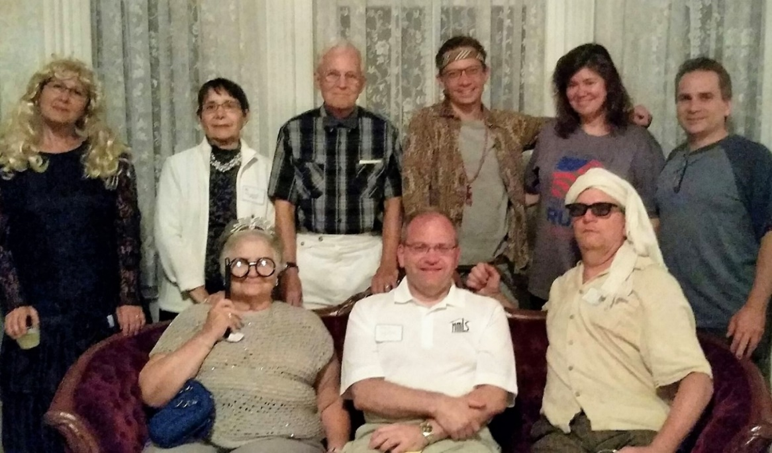
Weekend XVII | Paint ‘N’ Sip / Allerton Estate
From PT’s barbecue to the wonders of Allerton, from half-naked acting to our grand mansion vrooms, it was a Weekend to remember. And thanks to our master teacher, we all came home with priceless fungal souvenirs to keep the memories always with us.

- - - - -

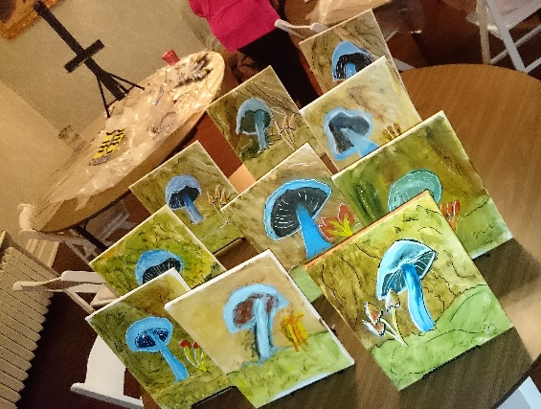
MushVrooms
Our rollicking, frolicsome, Pollocky dream
She layers thinly, he is all Sakrete.
Each bared our own spirit, like woodland Pucks,
Through Weekend. And if we birthed no Magritte,
Yet we shared full joys, loves and laughing yucks
Under swaddling skies – for once not too humid:
A mid-summer play with nonstop undressing,
Wondrous meals, gardens, our Vrooman,
Then, as if to grade school art class, regressing.
A fungus flourishes with fertilizer
And dank (and how do buried talents sprout?).
Though the Muse worried we’d murderlize her,
With beret, face hair and Master Mike, out
Came startling art. So cherish your special blue.
Till next year, when our friendships we all renew!
– YOS
++ Our Thoughts on Seventeen ++
Testimonial tagline
- “Nope.” (From Deb. Inspiration: Bryan)
- “We put the Weak in Weekend!” (Mike)
- He did it again! (Success of WwW, from Wayne)
- “Yesterday’s memories, tomorrow’s repressions.” (Bryan. Authorized 18 motto)
Suggestions for next year
- Go with “Weekend XVIII” (Heading in the opposite direction from Deb, Mike suggests Super-Bowleque Roman numeralizing.)
- Let’s go north (Wayne [Papa])
Darkest impulses/thoughts that raced through our minds
- At some point, stop counting. No one says Fourth of July Parade #242. (Deb)
- Give everyone only black paint for the sip’n’paint. (Mike)
- Acoustics in the dining room, walk to the hidden garden, fell on concrete stairs at last moment ☹ but OK. (Tommye)
- And from our eternally upbeat Weekender Wayne, with Darkest crossed out and Lightest substituted:
  - “Are you well? We both are?”
  - Allerton was fine. Now what about the other six Illinois wonders?
Top Tens
- “What the hell, Odell?” | Tommye, with an update of “To wander around.”
- “That’s not retro. It’s what it is.” | Mick’s observation of the Café 110 décor – and winner of the Most Insightful Comment about Art and Life Award.
- “Chicken ain’t up.” | PT’s Barbecue. In life, sometimes the second choice is the best choice. Oh those heavenly ribs.
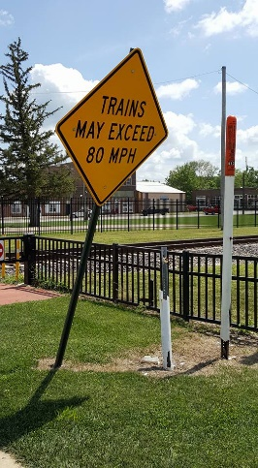
- “I wish I had worn more comfortable shoes.” | Deb, for the 17th year
- Wayne’s Dali-esque mustache | Deb
- “Nope.” | Bryan, staying on message throughout. From Deb
- “Blub.” | Mike attempted a comical reading of the Allerton’s rose bed signage. A nearby crane-sanctuary-like busybody offered an immediate correction.
- “I told George Wendt to go pound sand so I could hang out with you guys.” | Hage. Name dropping is an automatic Top Ten.
- Hanging cheeses. | Ask Weekender Lu about this one. Let’s just say it involves anatomy.
- And the winner of the Smallest Mushroom award … Tony!
- Trains may exceed 80 MPH | And given the neighborhood, we strongly advise them to.
- All Xmas cards $1.00 | “I’d like every one except this one” … “Okay, that comes to $2,454. Credit or debit?” At the Brown Bag in Monticello.
- Ha ha ha ha! |YOS found what was to become a rather tiresome laugh track app
- The Village of Farmer City
- “No passing zones not striped for next mile” | Piatt County Highway Department. New contest: How many ways can that be understood?
- Art class / Blue mushrooms / Allerton’s mansion / Hidden garden (where’s the garden?) / Good pizza / Enjoyed the antics of the Shakespeare group / Squeaky floor / Hearty breakfasts / Minooka “vintage” faire / Berets and hats / Lunch (ice cream) on Saturday with Lu and Spinas at small park with flowers. | Tommye with a flowering of memories
- Learning to paint by Mike | Wayne
- “Again? How much humility can I stand?” | Wayne
- Compliments to John for implementing a splendid WWW | Wayne
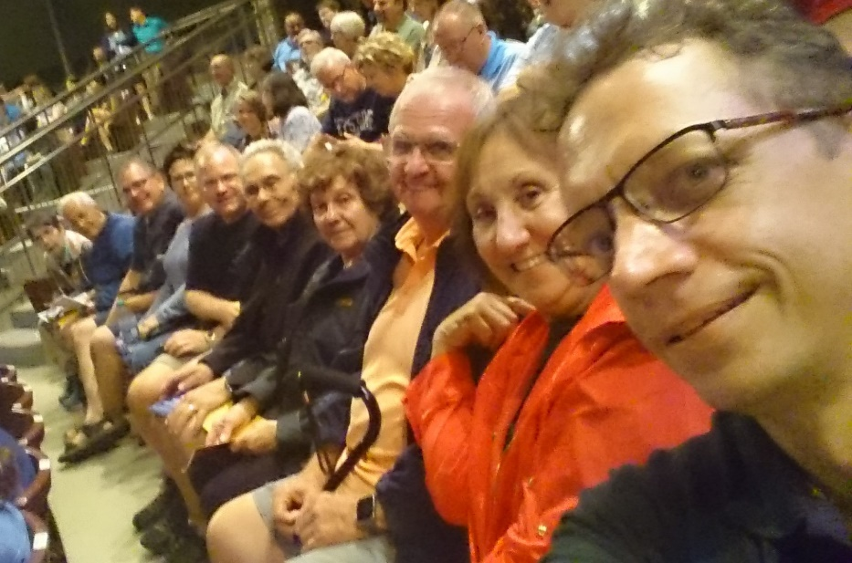
Official Drink of 17
The Ballistic Mizzle
If memory serves:
- 6 parts lemonade
- 2 parts whiskey
- 1 part cinnamon schnapps
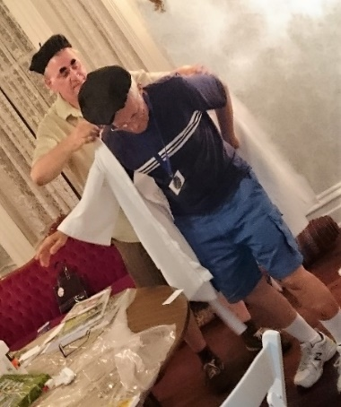
- A muddle of mint
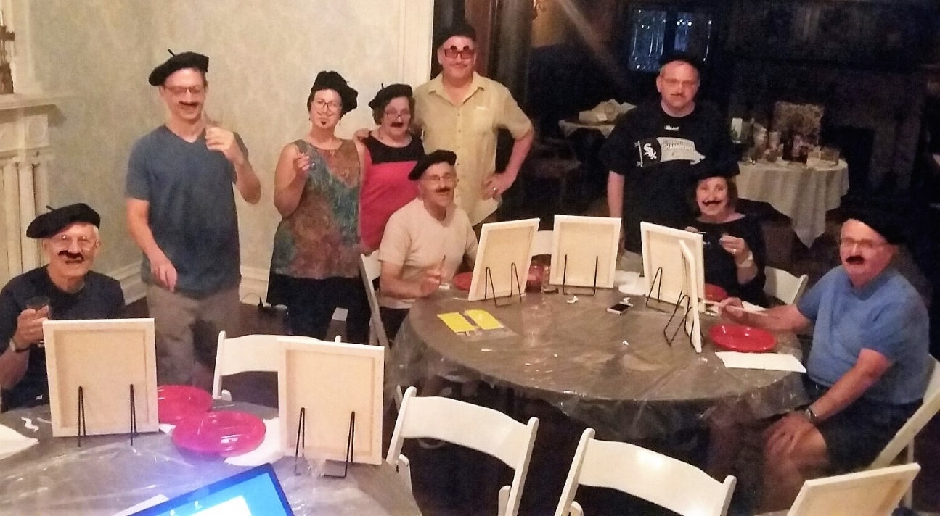
– YOS

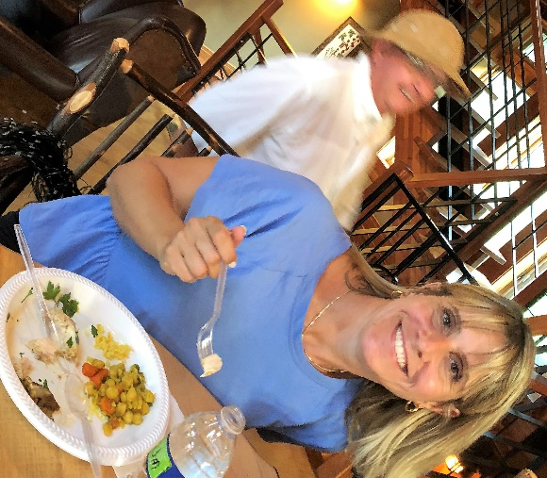
Weekend XVIII | Laffstock Comedy Barn Players
The Re-Aweekending.
Come join the Laffstock Comedy Barn Players. Friday, August 10th through Sunday, August 12th 2018.
Ever dream of performing in live improv theater? Of course you haven't! Now here's the chance you've been hoping for...
Through the talents of Weekender Deb – a trained performer who knows which end the laugh comes out of – we're turning our Wisconsin lodge into our own summer comedy camp. Get ready to learn the inner secrets of hilarity and get the guffaws flowing!

Blow, haiku siren, blow!
Weekenders – with Haiku Helper forms and a yellow whistle on hand – announced their creations:

Underwhelmed
Frank Lloyd Wright’s all right
Warehouse too much dust and must
Who needs the dumb bat
| Tommye. Malvolian of the Year

Bean There; Done That
Thou must mind the Bunn
Else thy pot runneth over
Thou hast wet thyself
| DD. Silver Medal

Untitled
First time Weekender
Looking forward to some fun
Great times with loved ones
| Jennifer. Bronze Medal – Tie

Wright Direction | A Bryku
We start with no guide
From the womb self-docenting
Where’s Bryan Schneider?
| YOS. Bronze Medal – Tie

Hunting lodge is nice
Not good for the animals
Eat corn no read meat
| Mick
Mary Jo kitchen
Food always so tasty
Join us for some fun
| Sharon

See Last Line
Opinions? You bet.
Traffic, cookies, jelly beans
Orchestrated rant
| Deb

today
Cedar Valley Lodge
Brought us all from our homes
Food! Wine! Improv! Friends!
| Tommye

Road trip
The date was now set
Spring Green is the next stop
Ready Set Let’s Go
| Sharon

All the World’s
Just me and a chair?
Clock ticks. Stares. No printed sheet?
* Gulp * Planet Improv
| YOS
Hey Doodle!
No. This isn’t right
Everybody turn around
Bucolic gridlock
| Deb

WWW
At Cedar Valley
With a bunch of weird people
Amused and confused
| Ed

You want to what
Oh for the improv
Let loose and let your hair down
A good time for all
| Sharon

The syllable count.
My place in the bathroom line.
Both five seven five.
| YOS. From “Haiku Helper”

Ha! Ha! Haiku | A Spiteku
Meteor oh my!
The sky was quite a beauty
Tonight was the best
MJ, Lu, Fran, Jen, Tommye, Wayne, Mick. By the non-play goers to mock those up the Hill

Friday Night
Silent Sentinels
Late Lights Streaking Sky Wonders
Early Light White Dawn
| Mike

Bump Trump
Trump is a road bump
So hold on till he is gone
Our people save us
| Wayne

I need a haiku
Love you to the moon and back
Happy to be here
| Lu
Reflections on the
bathroom habits of cows
pie pie pie pie pie
cows can come and cows can go
pie pie pie, pie pie
| Mike

Mickey
New pup in the home
And he won our hearts quickly
And likes his friend Jake
| MJ

G---- : Renku! Haiga!
We've all got our own problems.
Lou Gehrig managed.
| Deb. See “HSA Midwest News - July 2018”

Our Flyku!
Keep your spirits up
The father also rises
You can’t be grounded
| The Collective. To Joe

Our Comedy Barn
Laugh passed hand to hand
Hitchhiked through dice and docent
Good friends all thumbs up!
| YOS. Post-end wrap up

Afterku
Mooooon, throoough … On Sunday, a legation of Weekenders visited the Cradle of the American Haiku Festival in Mineral Point. We were admonished there – crossed forearm X for emphasis – that the English language is now considered too heavy for 5/7/5. Whatever that means. We shall ultimately ignore this warning. Meantime –

Cotton candy despair.
Ghosts of dead rainbows
On my tongue
DD | Haibun variation on a theme from Frogpond 37:2

| Soup to nuts: Our Top Tens |

Now that’s how you keep the bears away. | Weekender Wayne likes show tunes. From the non-play goers
Why would you go to Richland Center? | Lodge Owner Jennifer, mystified
Trip Soup | Entrée at Shifflet’s Riverside menu: ‘One Trip Soup & Salad Bar.’ (‘Waiter, can you carelessly walk this around again to make sure it’s been properly tripped?’) Copy of Strunk and White and an armload of hyphens are being rushed over
I’ve handled fifth graders before. | Lon, our patient to-a-point Richland Center guide.
It used to be a strip club. | Guide Lon, when asked if Honker’s Supper Club is recommended. From Bryan
It comes from rain. | Ed. From Bryan
The entire weekend was beyond my expectation … The food was terrible, the conversations were not funny, the people were not friendly. Let’s do it again next year. | “Bob” (possible actual initials: MM)
Directionally challenged caravans. | DD
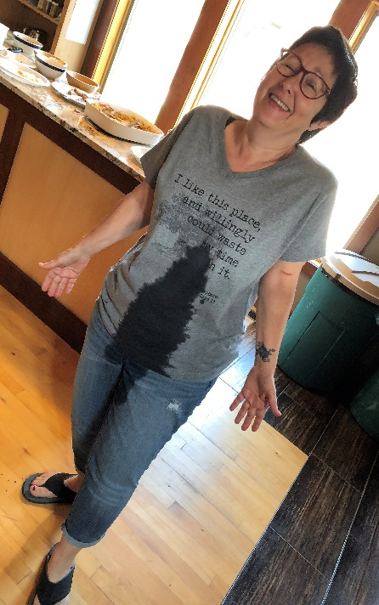
“Turn around.” | See above
How do you spell Hi Cue? Or Hi Q? | From Wayne
You drove in from where last night? | No cancelled flight is going to hold back Weekender Bryan, not when there’s a Hertz and two Israeli hitchhikers in Cleveland available
Zip! Zap! Zop! | MJ. Let word go forth of the newest Weekend tradition, ha-ha warm-ups to take place following the mandatory Friday reading of the Articles of War
Biggest Tragedy Since the Taliesin Murders. | Imagined headline if the Weekend stargazers had been less sprightly
I don’t want to play anymore. And you need to get me out of here. | Weekender Tommye offers to give up her LRC seat to another player. But the tightly packed seats did not wish to cooperate.
And when two lovers woo, they still say woo-woo-woo. | At Mike’s Café Americain
The only sance available was a Renai. | Bryan on Detroit. From Mike
I don’t see very well. | Driver Tommye breaking the news to her hitchhiker
Did you bring the cheese, Deb? | At Weggy’s, Sharon with the annual cheese conveyance quote
Mentholated wines. | Sometimes locally produced may be best consumed by locals
The Mick Move. | When asked how the ashy chardonnay tastes while still at the winery, inconspicuously rub your upper lip before ending with index finger pointing down
X. | Poet in Mineral Point non-verbally expressing his opinion of the traditional haiku formula. (See “Afterku”)
Voted Top of the Tops:
Why are you asking me? I’m not the docent. | Bryan has been vested with the Docent-of-the-Day emblems of office; YOS is feeling liberated. From Ed
I’ve been ginned. | Sharon’s announcement of victimhood on Saturday night
Is that Mistor Fog? | Spoken English can get tricky … Soup or salad? No, just an average one
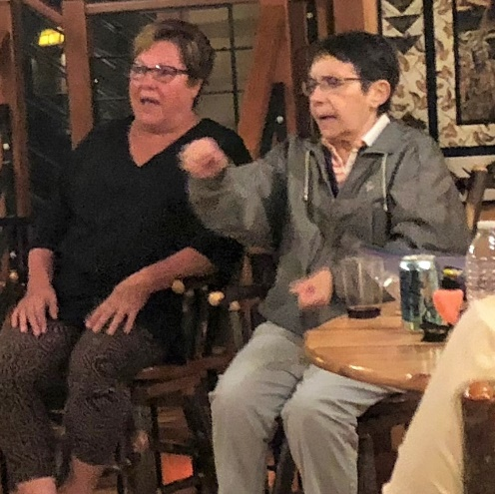
I have to finish the other half. | Ed had been called back early by his Celebrity Name Game team while taking a – break
What the hell is the Constitution, let alone the Preamble … Who the hell is the Lt. Governor of Illinois? And why? | Some of the test takers of the “Know Your Government?” GoH contest did not impress Principal Hoffman. From Wayne
Has Mike seen his ducks? | First comment by Lodge Owner Jeff – referring to Mike’s hunt for stamp-contest photos – immediately after nearly transforming four Weekenders into speed bumps on their Perseid-watching beds. From Bryan
Slow the f*** down! | Deb’s blurt immediately preceding the duck query (see above)
You were right to wet yourself. | YOS. Not satisfied as only Camp Comedy Coach, Deb entertained us with multiple liquid-based episodes. Starting on the driveway in Glen Ellyn
We’ve graduated from dithering to equivocating. | Ed, in Richland Center
And by acclamation – The #1 Top:
“Which one is the brake?” | Nursing home escapee Tommye, after her hitchhiker Sharon pleads for a break from their disturbing road trip
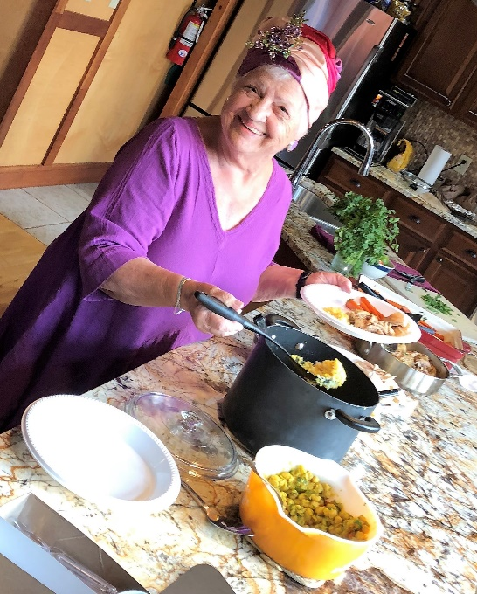

The Weekend 18 Kulm Kocktail Contest Winner:
Fran!

| From the Official Evaluation Form |
Quote whoredom: Our Weekend Tagline
- You just might wet yourself! | Bryan
- The hugs are free! After you sign a waiver.
- Deb’s reference to the owner said it all | Bob
- Thanks, John, ya done good! | Wayne
- So funny Deb will wet herself | Mike
            - The authorized XIX motto
- The future is now, be yourself | MJ
- Enjoy our exciting gravel beds! | YOS

What’s the punchline? (Extra credit for referring to a fellow Weekender or feature of XVIII.)
“And the first thing I said to the surgeon after waking up from the operation was …
- … lettuce, tomato, no onion, mayo on the side.” | Mike
- … Doctor, how do I get this Bryan Schneider off my head?” | YOS
- … I don’t care what Lu told you. I’m not Jewish.” | YOS
- … it was my left arm that was broken, you goof!” | Wayne
- … do I still have my humors? I have to participate in Deb’s improv seminar.” | MJ
- … did you wash your hands before you started?” | Bob
- … why was your hand there?” | Bob
- … did Mike find his ducks?” | DD
- … slow the f*** down” | DD

Thoughts/suggestions for 19
- Zip Zap Zop ziplines | Mike
- White Sox ballgame | Wayne
- Breakfast cheese course. Consider scheduling with the Perseids if Weekend viewing is advantageous | Bryan
- Water fun | MJ
- Don’t let John do the planning | Bob
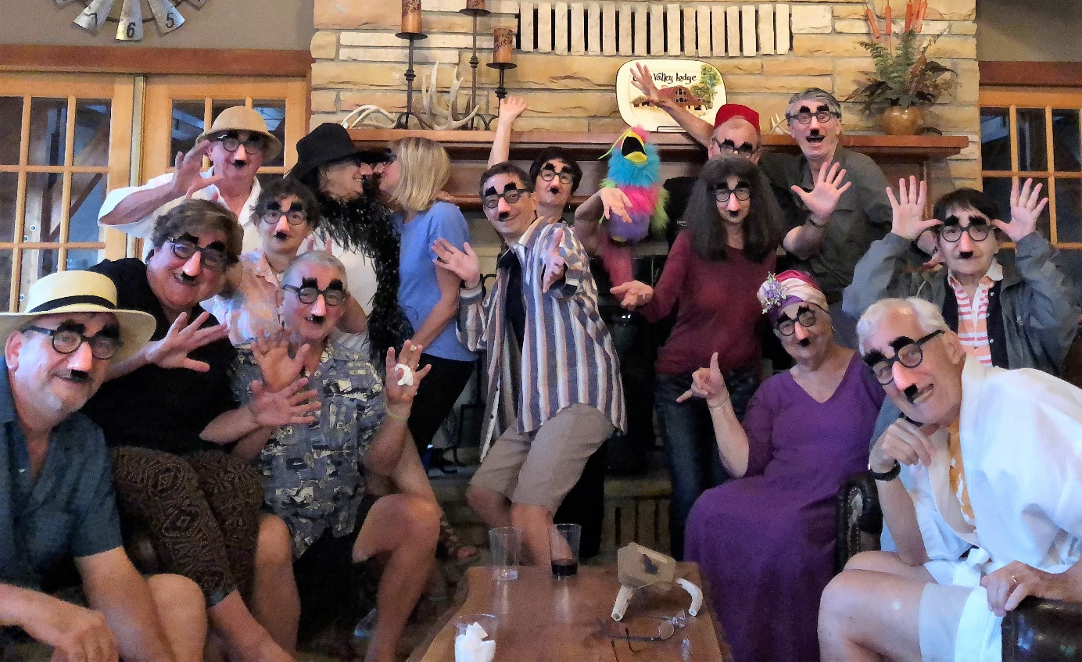
Weekend XIX | Aloha Wisconsin
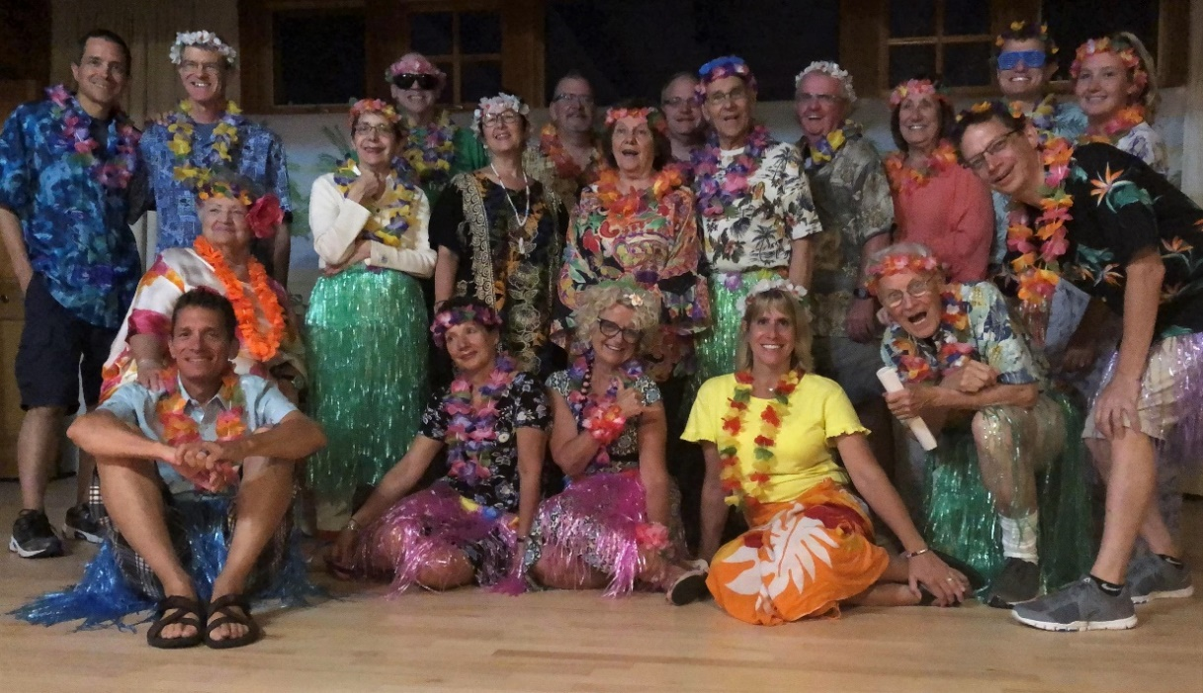
Fruity drinks, golden sun, gently swaying bodies – it was, after all, a stonking great Kocktail Kontest – and all the enchantment of the tropics. With far fewer of the devouring lava flows. Our Aloha Wisconsin Weekend!

‘Hips of Kilauea’ Hula Contest
Led by our senior Weekenders, teams of three created their own hulas to the tune and theme of Little Brown Gal. Some selected lyrics:
Team Tony, Mary Jo and Erik.
Went to rent a pontoon! We had a store in mind
Run by two local loons who didn’t like our kind.
(Refrain.) There’s no little brown hair from a little brown dog
On a little pontoon in Illinois.
So out went Mary Jo and Kurt. And Deb and Bryan too I know.
On the lake they go, but with Millie No No No.
(Refrain.)
They tried to catch a fish and caught a little sun.
Made a watery wish and had some watery fun.
They brought the pontoon back. They cleaned the rental boat.
But the loons began to crack. They cried Millie’s hairs from Millie’s coat.
Three lawyers began to vent. Ed Ludwig made a fist.
Our dog is innocent. So they made a list.
(Refrain.)
Where is the land Green and summer-like Spring?
We are very keen. Cedar Valley is just the thing.

Team Scream: Fran, Deb, Jon
Aloha.
We share with you a tale from a weekend past.
Our people were led by the spirit guide
Docent Bryan to the Richmond Center.
He brought them to the barren and neglected
A.D. German warehouse designed by Frank Lloyd Wright.
They were were excited to explore the interior of
This gem, but first were led up
Winding stairs to a small dark theater.
On a television they watched the
Orientation on the history of the warehouse.
As they stood up to go, a commotion was heard.
Out of nowhere, a bat appeared and headed
Straight for Mary Jo.
With a blood curdling scream, she ran down the stairs,
Out the door and down the street, never to
Be heard from again.
Mahalo!

Team Rosemary, Jennifer, Bryan [Winners! Hips of Kilauea award]
All About Tommye
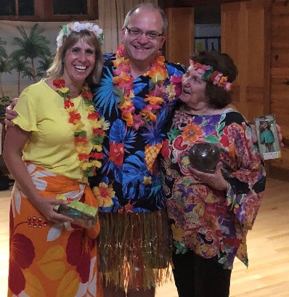
Tommye is so fair and she hulas for me.
She has lots of flair but it’s not easy to see.
(Refrain.) It’s a little white gal in a little grass skirt
In a little wood lodge in Wisconsin.
She’s an improv blast. I’d hate to tube in her wake.
But she doesn’t know her gas from the brake.
(Refrain.)
She has the key to each and all our hearts
It’s easy to see all her hoomalimali.
(Refrain.)

| Top Tens |
There’s a chaw theme? | Erik, on learning we’re getting buckets.
That’s an NP problem. | Showing off both our grasp of high-level concepts and our inability to pack a car.
Vote for Joe! Vote for Joe! | Perhaps not in the Sistine. But our conclaves are more fun: They include group chants. At the election of the first Funnery Sergeant, Office of Coordination and Direction.
We impeached Joe. | Five hours later, our first coup. Lu made the announcement.
I think we made a mistake. | Fran, after seeing the results of impeachment.
Aren’t we where sticks come from? | Erik, on our search for a docent scepter for Bryan.
And he’s so professional! | Bryan frames the perfect group photo for the playgoers behind us. See photos.
I’m probably fixating on the wrong thing. | YOS
It’s probably not a good sign that there are chalk outlines of children all around. | Erik at Trail Break Pizza. See photos.
Please tell me Erik is wearing pants under his skirt. | Bryan’s hope.
Whip that out! | Fran gets demanding.
It’s hilly because it was cold a long time ago. | Weekender/geologist Wayne.
Just humor him. | A mumbled comment about YOS, during the Awards show.
Voted Top of the Tops …
Where’s my bra? | Rosemary wants her prize.
It’s like people without a vine and it’s like a farm with a provine. | Andy hard at work at improv.
So we need to go to Wal-Mart for ammunition and a hula hoop. | Joe’s shopping list.
I can’t keep it up. | Joe. With the second item on his shopping list.
And our number one Top Ten! …
We just need a circle and a chair! | Bucket Master Mike didn’t think it would be this challenging.
| Kona Kocktail Kontest |
- Rum & Coke-O-Nut | Bryan
- “Death in the Afternoon” | Wayne. Champagne and absinthe. A recipe Ernest Hemingway gave his Uncle Carl.
- Hawaiian Launch. | YOS. Rum, coconut milk, pineapple juice
- And the winner of the Kontest! – Peachy Keeny Bellini. | Fran. With freshly pureed peaches – mmmmm …

The Weekend Tagline!
- I hope I can get the Hawaiian music out of my head when I get home. | Mick
- Weekend. It’s not just for Saturday and Sunday anymore. | Mike.
- Impeachment works. | Unknown
- Let’s hula. | Jennifer
- Like sunshine, lollipops and rainbows. But with more drums. | Anon.
- Are you well? If so, so am I. We are well together. | Wayne.
- We are not the hula pros after all. | Andy

The moment I realized our Hawaii Weekend jumped the shark
- During the drum session. | Mick
- When Mick “Julius Caesar” Maloney danced the hula | Mike
- The minute I ate a cookie. | Mary Jo
- Mahalo. | Unknown
- Drum Circle. | Jennifer
- When I took pictures of the towel hamper for sentimental reasons. | Anon.
- Grandpa trying improv. | Alex
- Hearing Wayne’s improv sayings. | Jon
- When Jane Addams became a president’s wife. | Andy

More Evaluation Form commentary
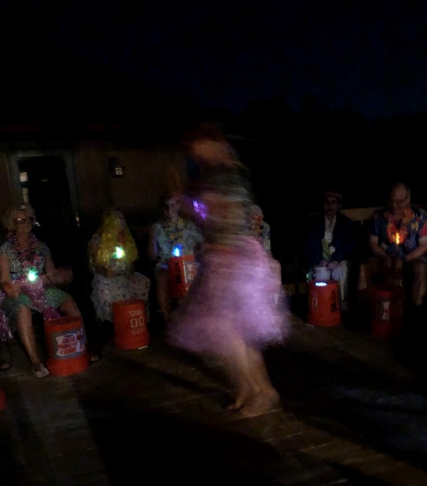
- Blindfolded wine tasting.
- Next year’s Weekend location: John’s House (Mick), New Buffalo (Joe)
- More of the same, God willing. A prayer for God’s blessing on all of us to bring us together. | Wayne
- Bigger guns, outdoor stuff, more improv games. | Alex
- More guns and shooting things. Seriously, more game playing. Karaoke. | Jon
- House on the Rock. Ribs. | Mike.
- More bike riding. | MJ
- Keep patrol/plunger job. | Jennifer
- More relaxed time. Too many organized activities. | Fran
- Theme ideas: Kitsch, 60s/Woodstock

Honored inductees at our Awards Show Breakfast [new!]
- Kona Kocktail Kontest | Fran!
- Gown of Humility | Rosemary!
- Funnery Sergeant, Office of Coordination and Direction | Joe*, Bryan
  - Cadet Neatfreak | Rosemary!
- Top Ten | Mike!
- ‘Hips of Kilauea’ hula contest | Rosemary, Jennifer, Bryan!
* Impeached by mob acclamation, upon which office devolved to runner-up

Weekend 20 | WiFiW
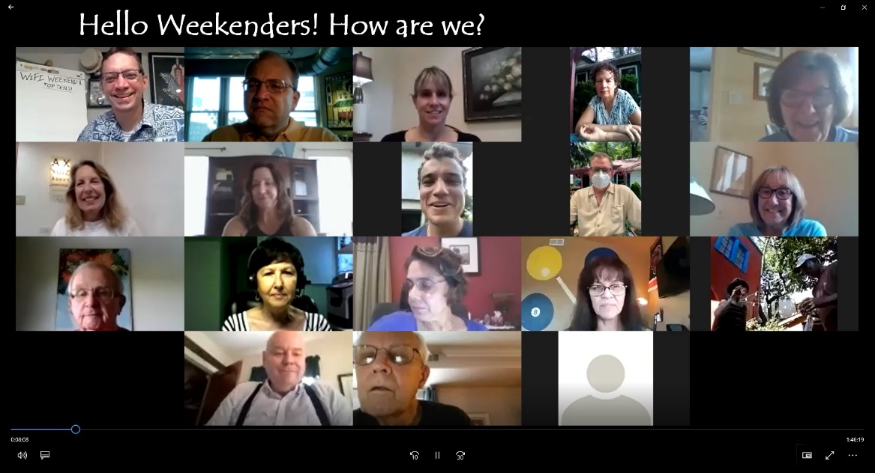

Laughs, haikus, Tops, costumes, improv, theater and raised glasses!
From coast to coast, we did it all. Without having to ever gas up or wait for an available shower. And for the first time ever (that you know of), we recorded an entire Weekend so you can binge watch the highlights over and over.
- Dress Up contest winner: Jennifer!

A Continent of Ku

We-Ku
Our summer party
Joyful congress of fast friends
A precious treasure
| Mike
Untitled
Halcyon Spring Green
Not so now the experts say
So, in Zoom we trust
| Bryan

The Robe of Humility
I know I did wrong
I washed it so many times
Get thee robe gone
| Rosemary
Jigsaw (A true-ku)
Random shapes of green
Which lock together, or not
Last piece found on ass
| Andrea

What to do? What to do?
Time just flew
Here I am again
With no haiku.
| Elizabeth
‘I’m going to do whatever sounds good.’
Come, fill Solo cups.
Drooping peach boughs laugh and urge:
Bellini us now.
| YOS (With apologies to Omar Khayyam)
Untitled
Bryan Debra CHEESE!
Friends family years of memories
John Hoffman, Thank You!
| Mary Jo
Haiku Pressure
The sun and the moon
Make me smile every day
Yay made a haiku
| April Bredy
Untitled
Need a new usage
My casino tuxedo
I’ll wear it to church
| Erik
Heaven & Earth
Zoom since we are home
Fran is looking down on us.
We are together.
| Jennifer
Untitled
The Perfume of Off
Sweating and freezing at once
Snoozing through Act Two
| Deb
Untitled
Summer is here, yea
Cannot use pool. Damn Covid
So jump in the lake.
| Mick
Whistle Blower
Haiku emerging?
Why don’t you blow the whistle
It is disgusting
| Mike
——-
And our Malvolian of 2020! ….
A family trait
Tribute to cuz Fran
I want your philosophy
Live without judging
| Lu
—————
A post-Weekend lament …
Zoomed again today.
But it was not the same
No champagne, no zany, no hat,
There was none of that.
Math and death, oh joy!
To fly away one day.
| Elizabeth
Tops of 20
It’s the obsession with cheese. | Talking about what we most miss about real-live Weekend, Elizabeth nailed it with an annual cheese-based quote.
You just woke me up. | Tommye on how she’s been doing lately.
I use it when I’m in the bathroom. | Tommye on a Fran hat she wears to protect herself from a ceiling air conditioning vent.
Get thee robe gone! | From Rosemary’s brilliant haiku.
25% of the time you should be thinking about toilets. | Mike as an efficiency expert giving bad advice.
Sounds like a personal problem. | When a haiku emerges. From Sue.
A pirate festival? What?! | Explaining her costume, Deb thought we would let her just gloss over her past life.
I like the little knob on top. | Please see Andrea’s hat.
He haikued in his pants. | When a poem just emerges. From Mike.
You can definitely see the Hob and Dick. | From Act 2, Scene 3 of Coriolanus, blended with a discussion on the shortness of our GoH. Which we will now be referring to as the “woolvish toge.” From Mike.
And our Top quote of 20 …
Eat them or put them in your underwear. | For the record, Sue was a kindergartener giving bad advice on not losing your keys.

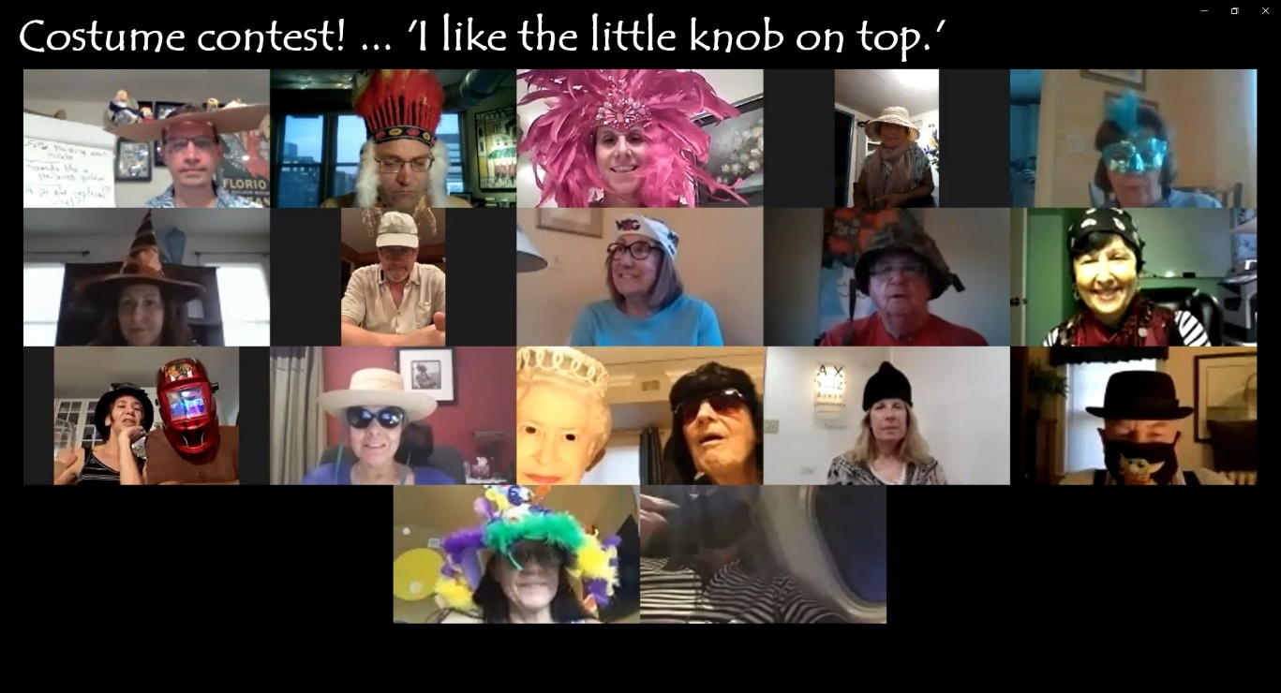
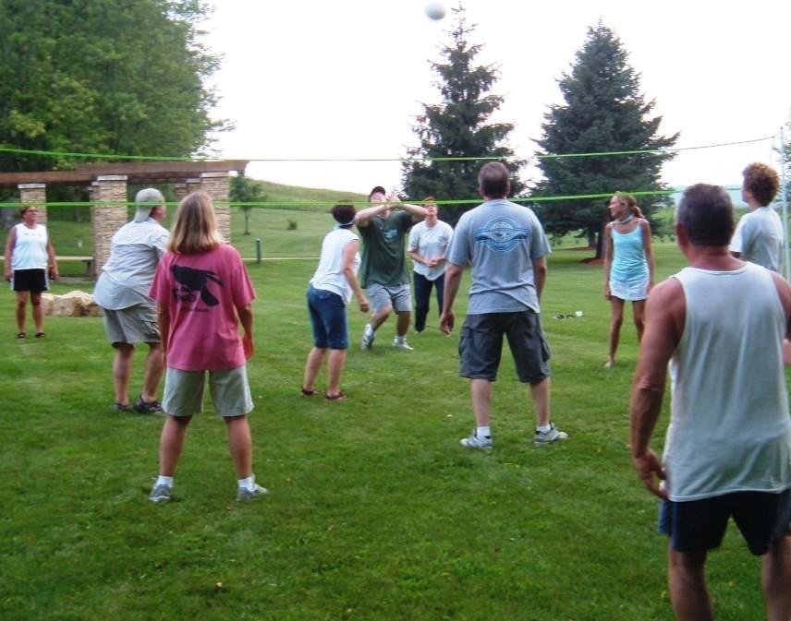
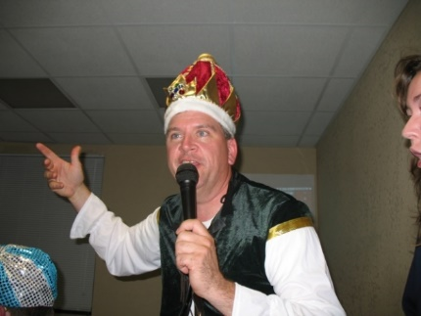
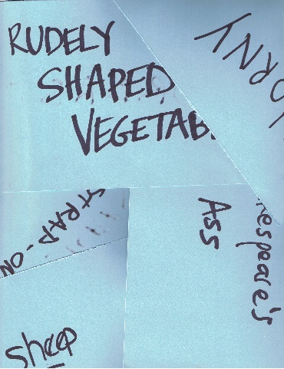
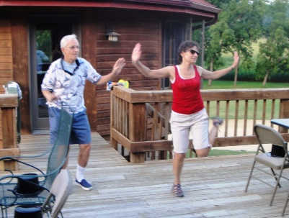
More Remembrance of Inanities Past --

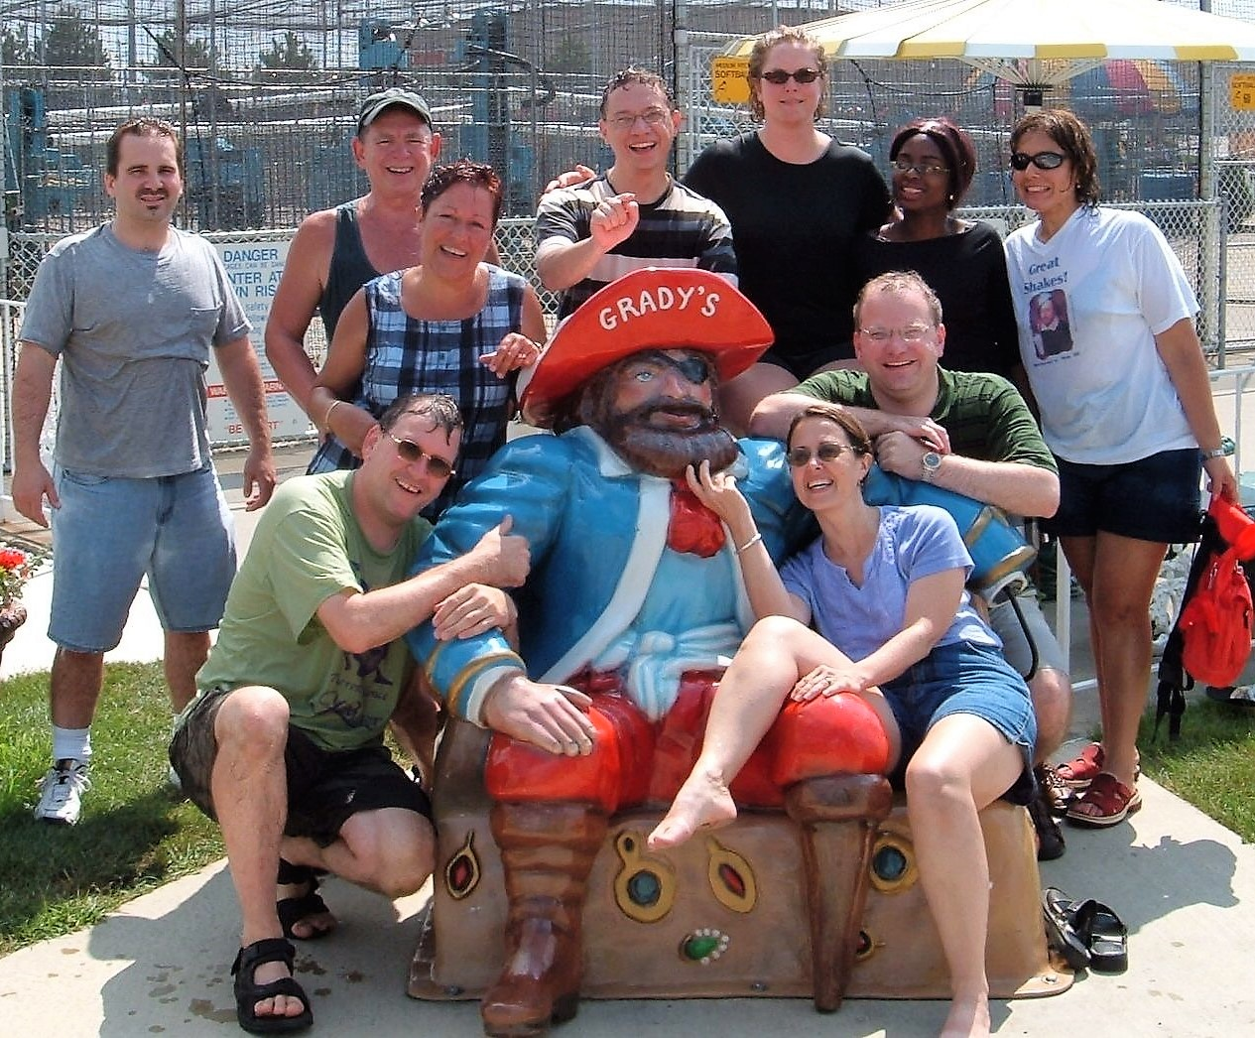

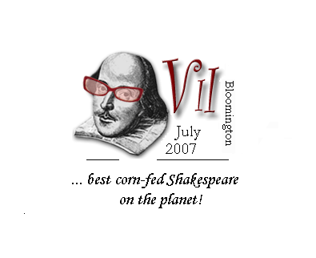

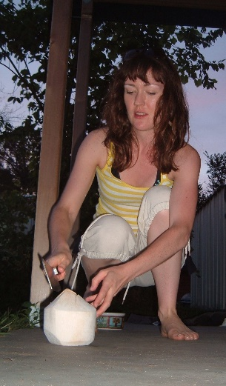
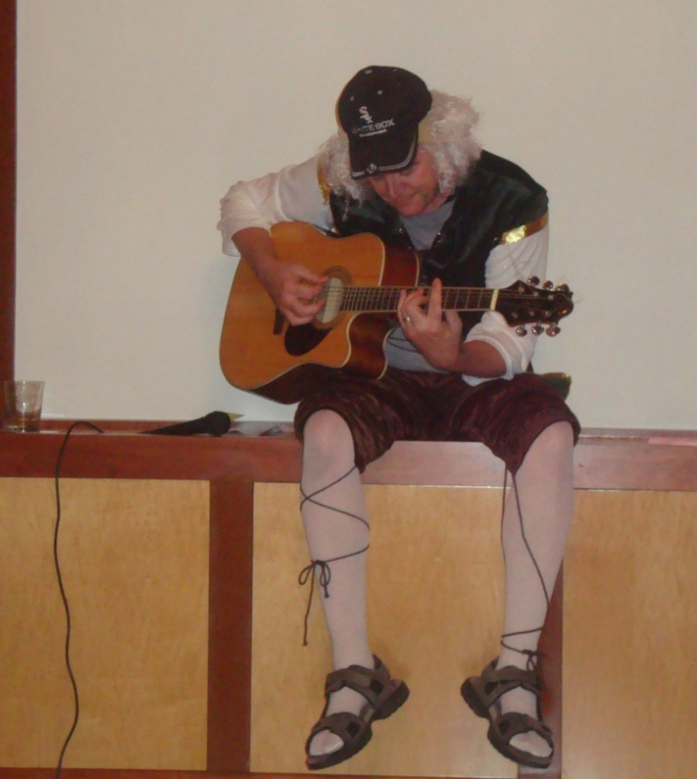
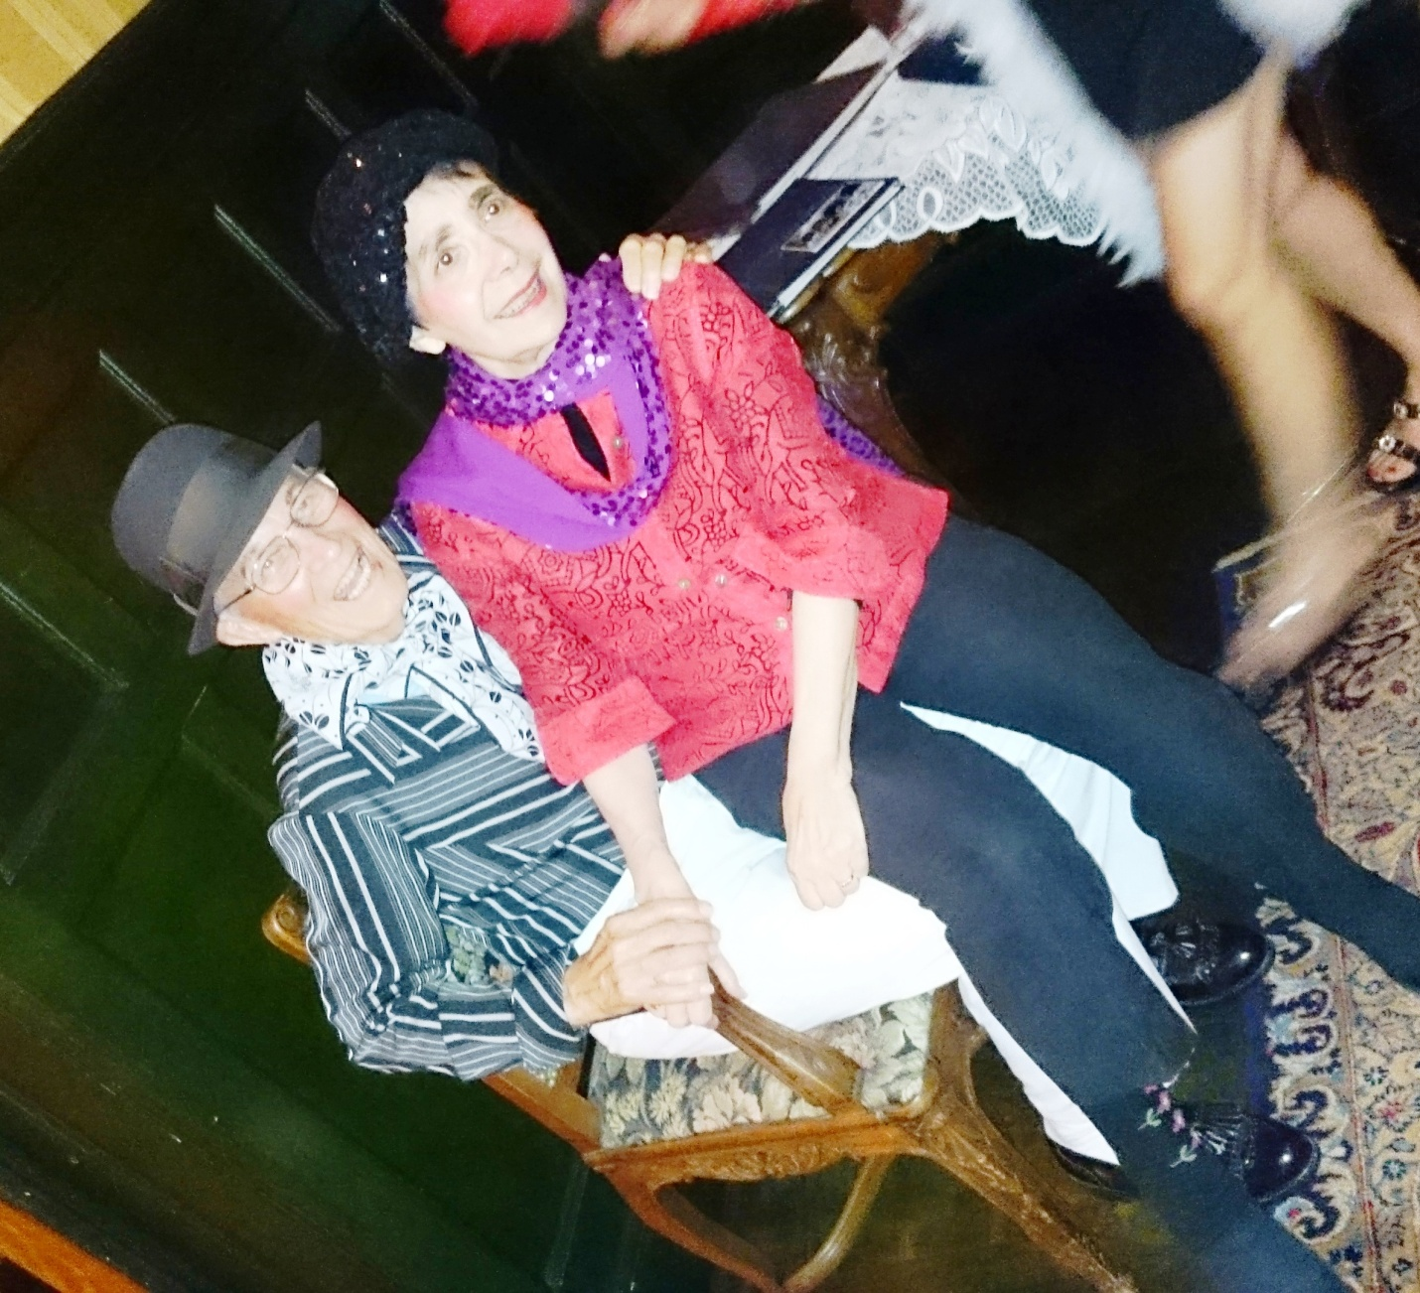
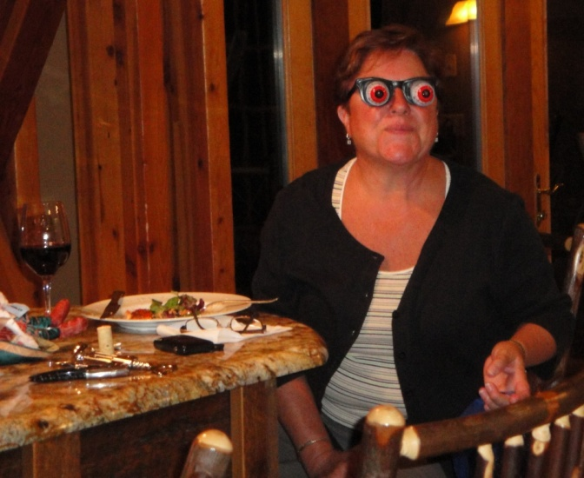

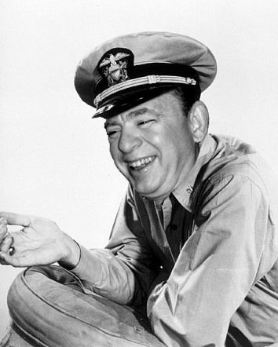
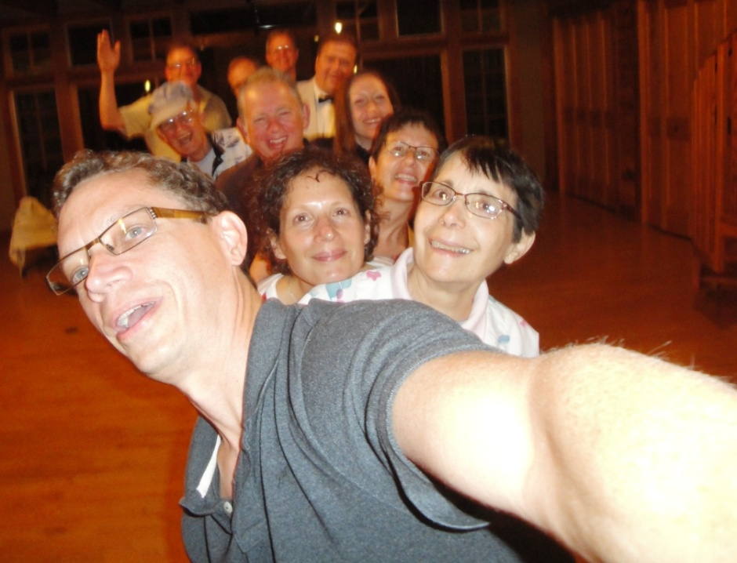
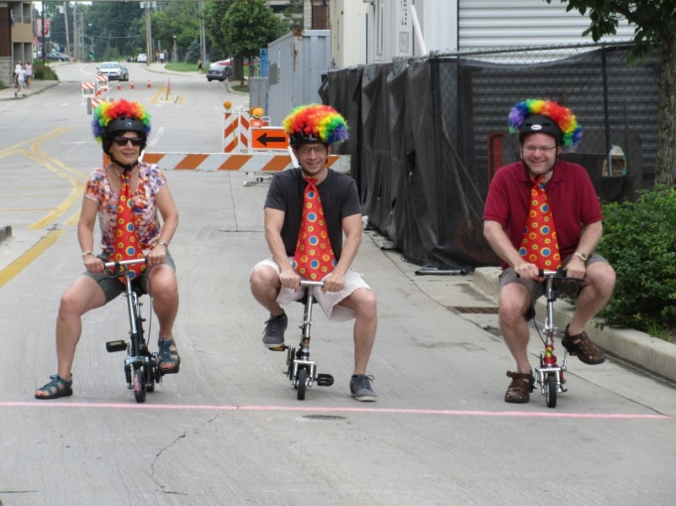
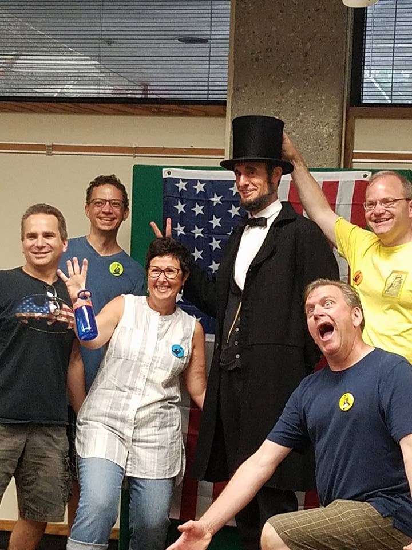
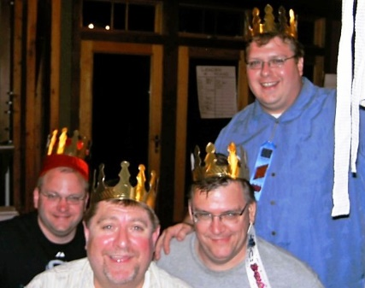

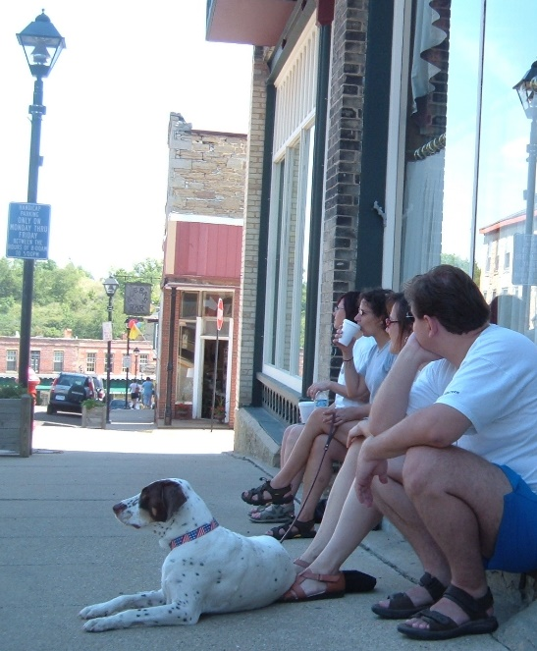
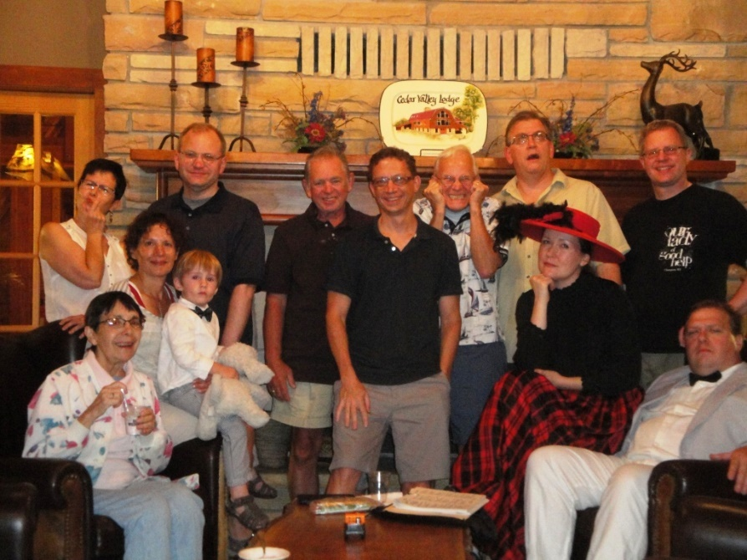
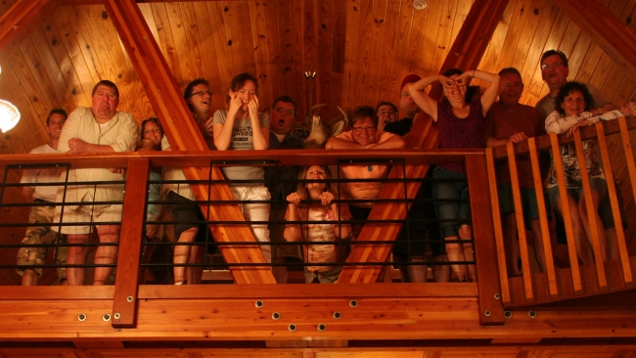
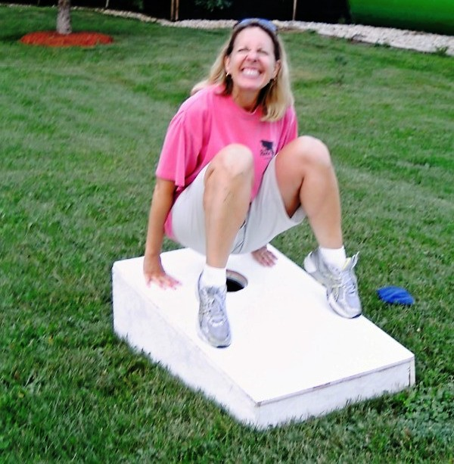
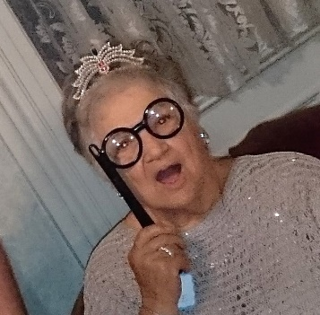
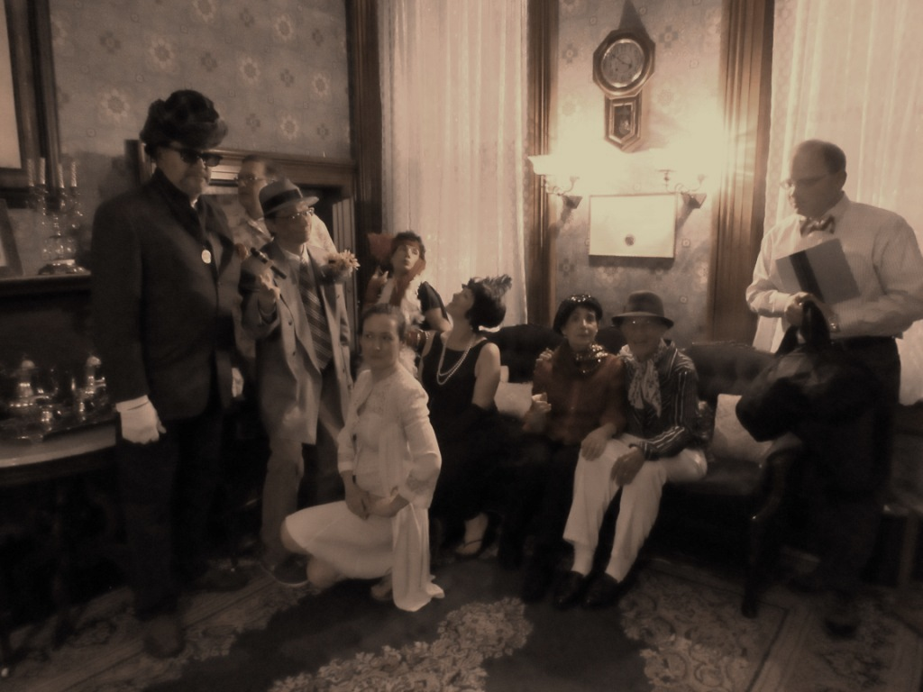

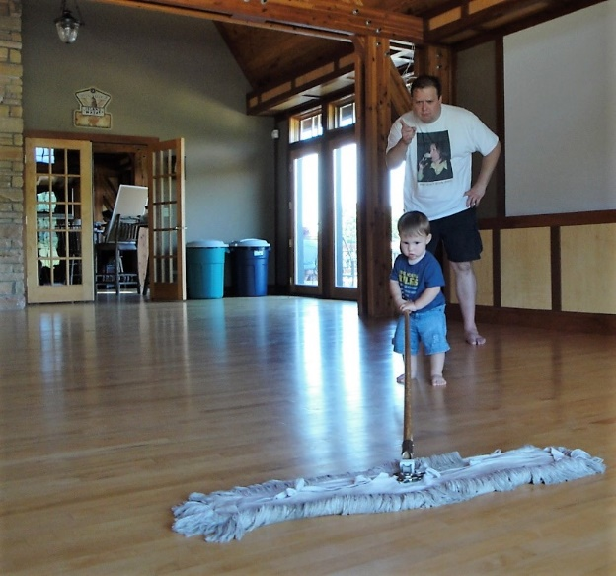

‘Thy friendship keeps us fresh’ – Wm.
Till next Weekend…

You are encouraged to ask Weekender Mike where one might wake up after a night with Deb’s cheese tubs and really sweet wine.
Continuing apologies to the Pixilated Weekender.
WwWm Three shout out to the Twin Cities Steak and Shake and the inventor of single serve containers.
Grady’s Family Fun Park is ironically not ADA compliant.
Btw, has anyone ever seen Brackish Stink as a green paint sample at Restoration Hardware?
Art historians believe Weekend Six witnessed the creation of the first small appliance-based Japanese verse, the Brylenderku.
RESOLVED, “our kind of people” had a little more fun riffing on Match Game then with the Gribbles that year.
Aris-TOPH-anes?
Yes, yes, we know that’s not how it’s pronounced.
To be fair, GoH is only 40% synthetic fibers. Anyway, here’s to a happy X and many more to follow!

